**Table of Contents**

**DESIGN GUIDELINE**

***DESIGN CRITIQUE/ REDESIGN***

***WHAT CAN WE DO DIFFERENTLY?***

**INTERACTION**

***SPECTRUM***

***Direct Manipulation***

***Types of interactions***

***CHANGE OVER TIME/TRANSITIONS***

***NAVIGATION***

***SEMANTIC ZOOMING***

***FOCUS + CONTEXT***

***DEGREE OF INTEREST (DOI)***

***OVERVIEW + DETAIL***

***FILTERING & DYNAMIC QUERYING***

**VIEW**

***DESIGN CHOICES FOR MULTIPLE VIEWS***

***MULTIFORM***

***SMALL MULTIPLES***

***PARTITIONING***

***TRELLIS PLOTS***

***RECURSIVE SUBDIVISION***

***LAYERING***

***SUPERIMPOSED VS JUXTAPOSED***

***DUAL AXIS***

***DYNAMIC LAYERS***

**EVALUATION**

***1.*** ***Problem-driven vs Technique-driven***

**a.** **Problem-driven**

**b.** **Technique-driven**

***2.*** ***The nested model (important)***

*Domain Characterization*

*Data & task abstraction*

*Encoding & Interaction*

*Tasks*

***DESIGNING VISUALIZATIONS***

1. What is design?

2. What is design not?

3. Form & function

4. When do we design?

5. Why does design matter for vis?

6. Evaluation methods

7. Quantitative vs Qualitative evaluation

8. Internal vs external validity

9. Scope of evaluation

**Review with TA**

# **DESIGN GUIDELINE**

* 2 key components: purpose and audience
* Principles 1:
  + Visualizations should show all of the data and only the data.
  + Use the best visual channel available for the most important aspect of the data.
* Frist impression should have:
  + Contribution
  + System design
* Excellence graphic: complex ideas with clarity, precision and efficiency 🡺 gives viewers the greatest number of ideas in the shortest time with the least ink in the smallest space.

TUFTE’S INTEGRITY PRINCIPLES

* Show data variation (contribution of data), not design variation.
* Clear, detailed, and thorough labeling and appropriate scales
* Size of the graphic effect 🡺 directly proportional to the numerical quantities (“lie factor”)
$The lie factor= \frac{Size of effect shown in graphic}{Size of effect in data}$

* Use a baseline (đường đo lường hiệu suất và tiến độ của dự án) that shows the data not the zero-point.

🡺 Death to Pie charts: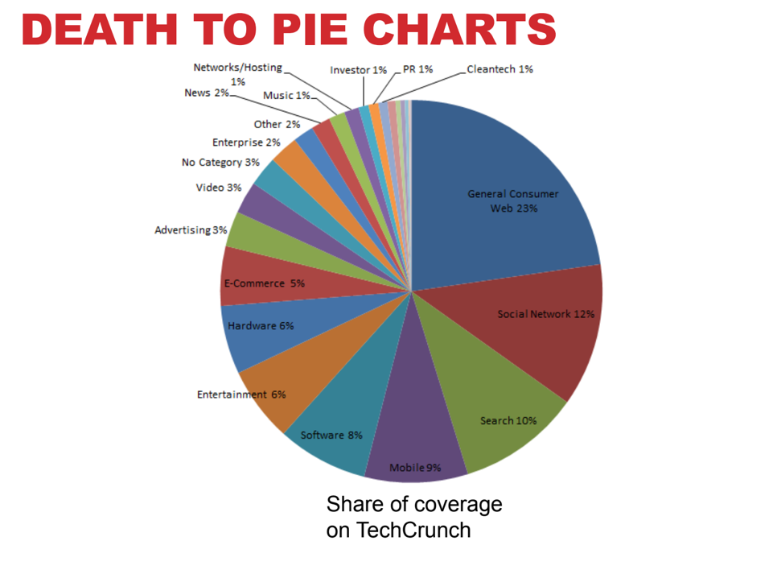

* Too many items
* Divergent of color
* Must change into bar chart  
   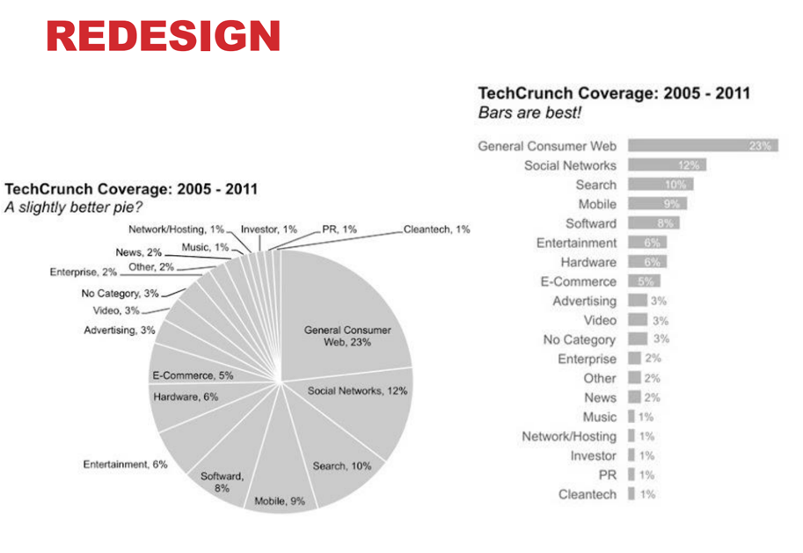

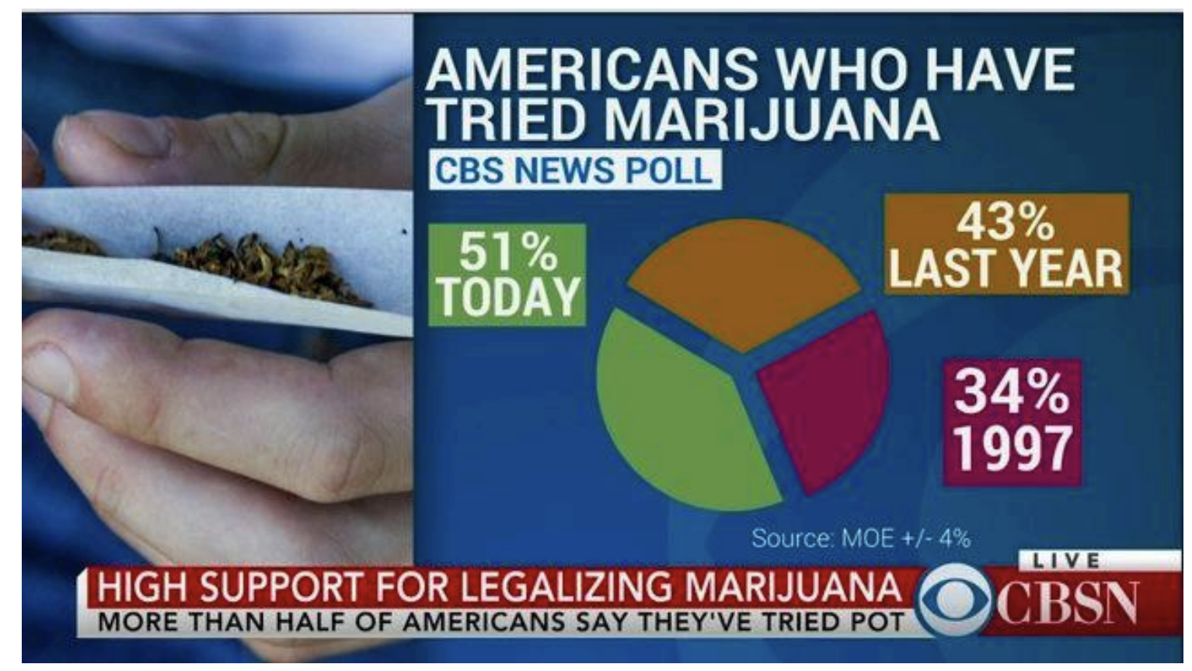

* The total is not 100%

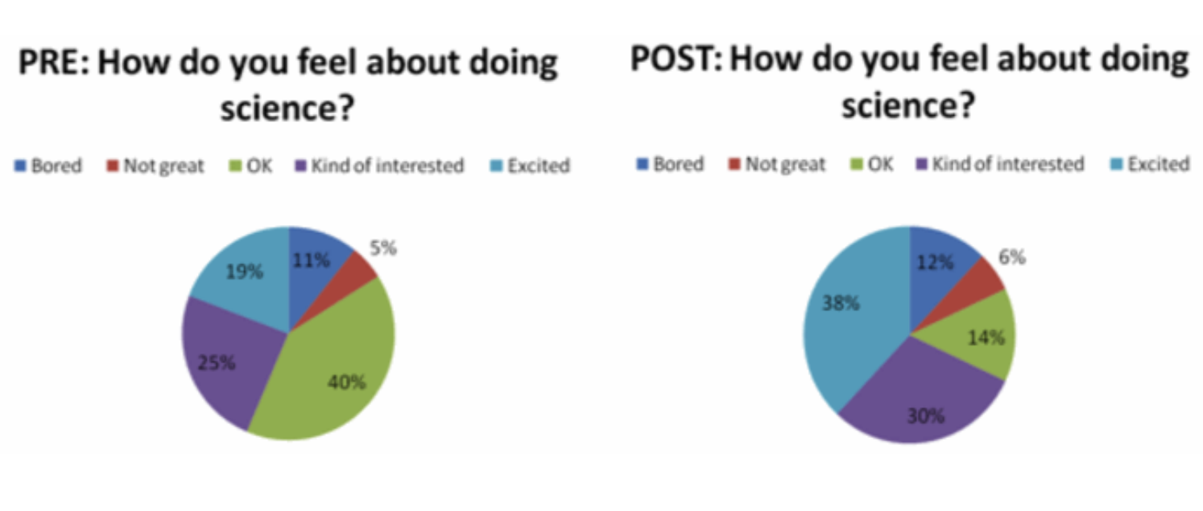

* Some alternative ways to redesign these graphs:

+) Number Directly 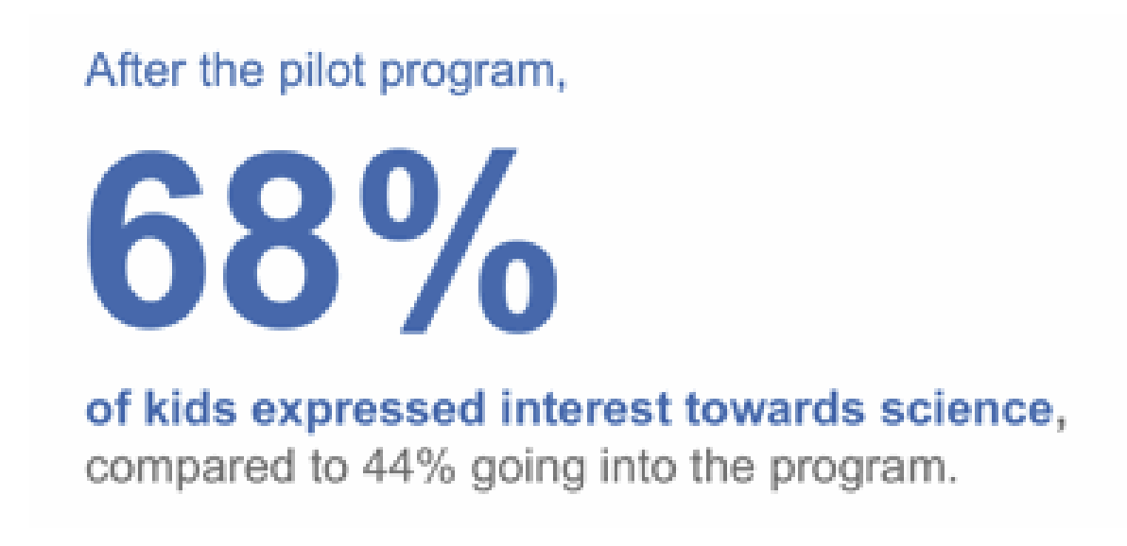

+) Simple Bar chart

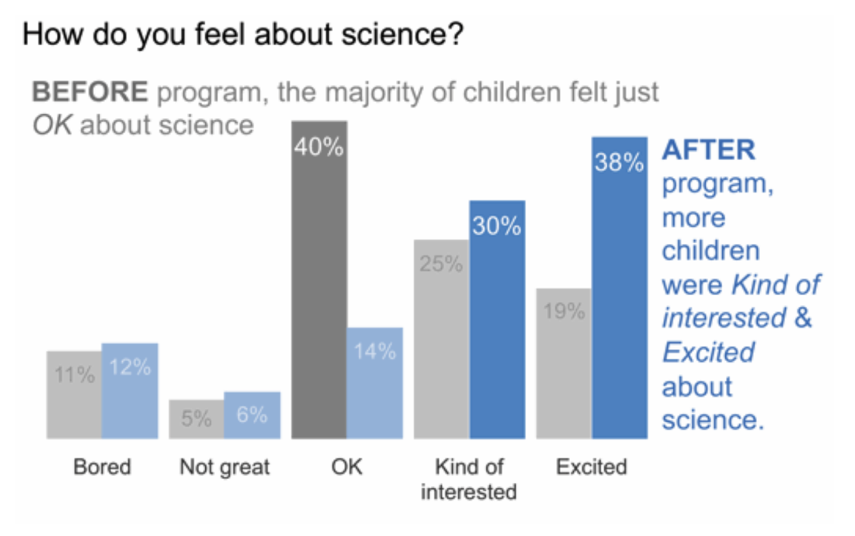

* 100% stacked horizontal bar graph.

+) Slope graph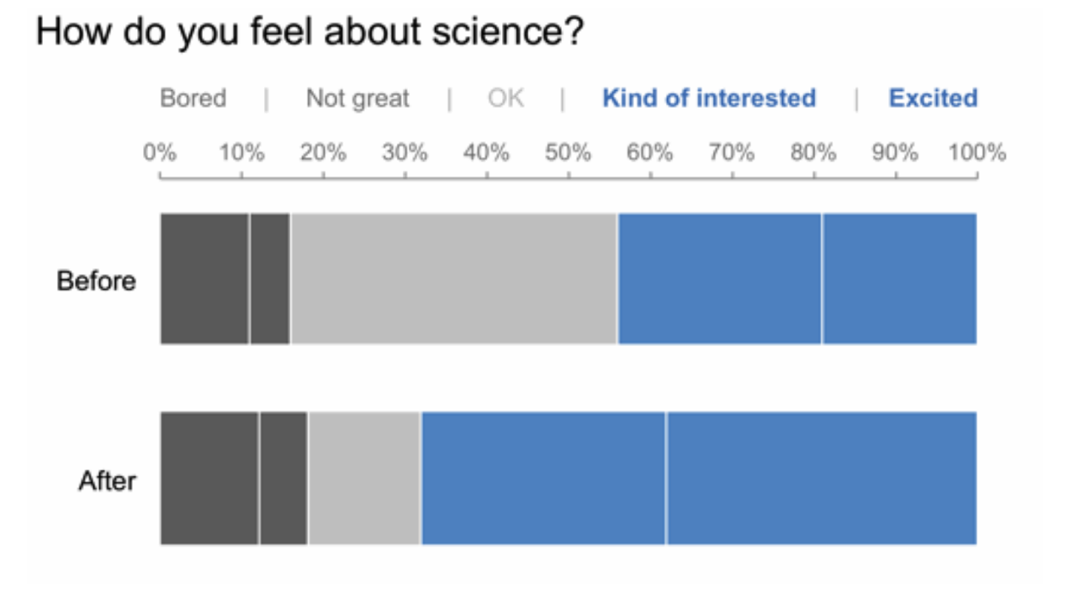

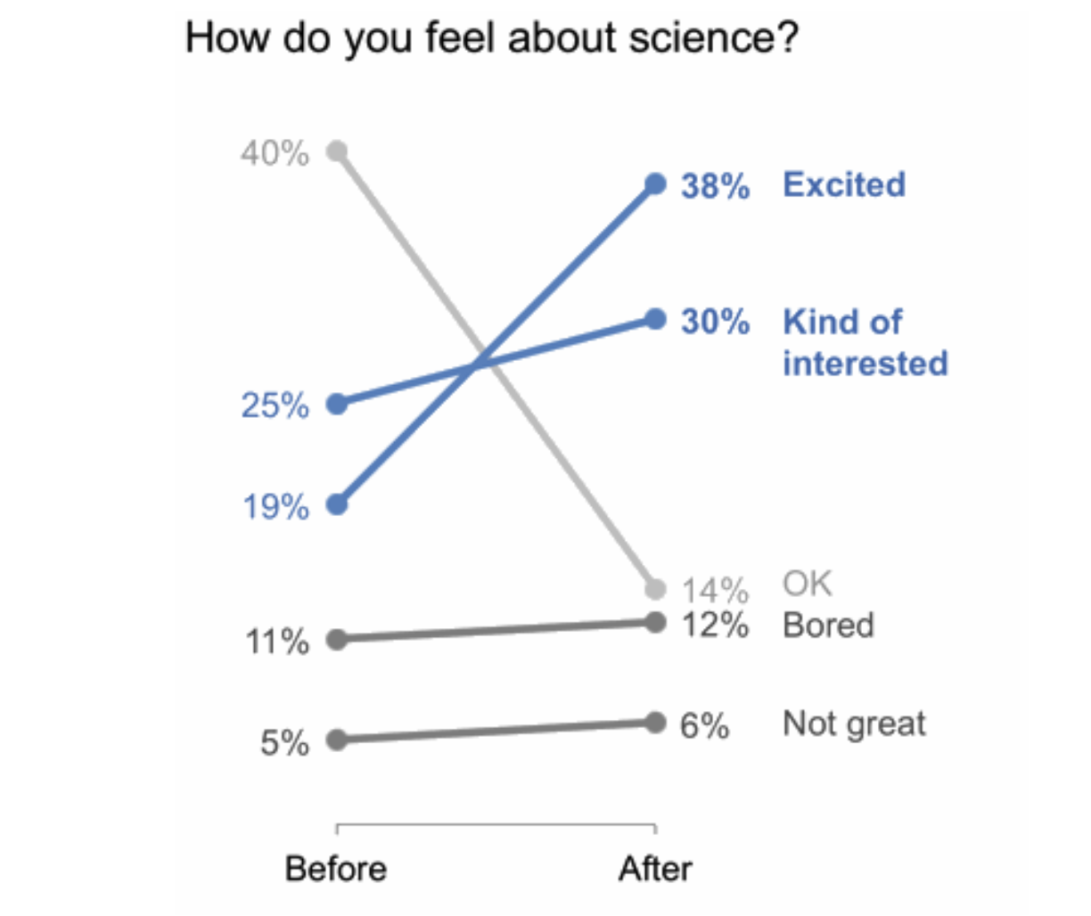

## **DESIGN CRITIQUE/ REDESIGN**

= evaluate the given chart and redesign it

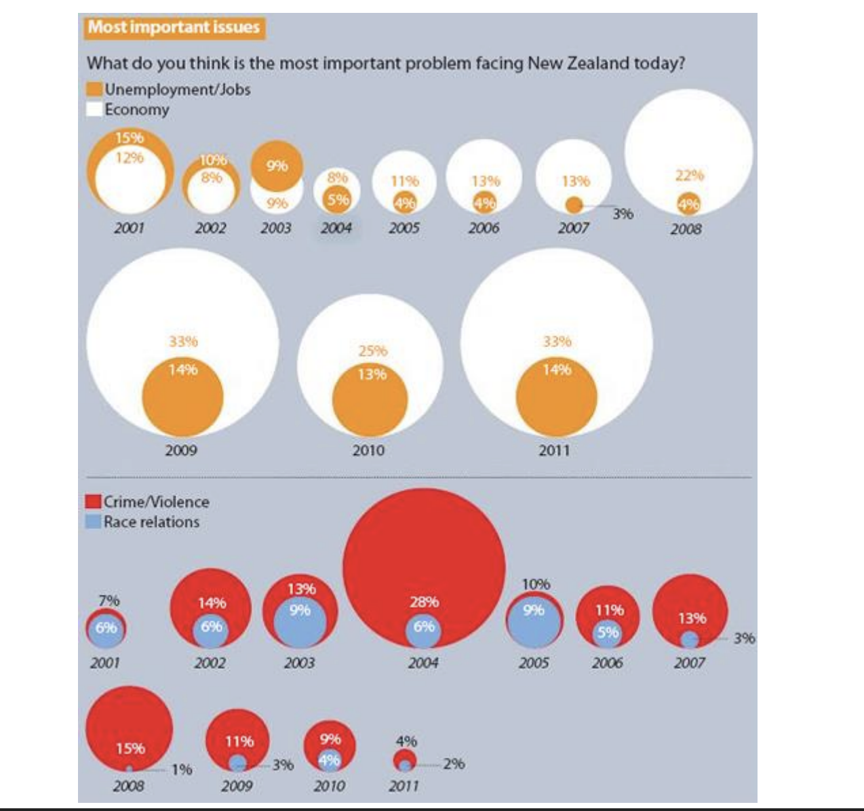

Problems of the given figure:

* Size of the circle
* Hard to compare.
* When remove number => hard to say anything.
* Circle too small => to put the number inside
* **Need to define the purpose of the graph:**
  + Mark, attribute
  + Purpose is…
  + Entity is…
  + Channel is…

* **VISUALIZATION DESIGN PRINCIPLES**

- Avoid chart junk? => No, it is dependent.

| PROS | CONS |
| --- | --- |
| Persuasion (sự thúc đẩy) | Biased analysis |
| Memorability | Trustworthiness |
| Engagement | Interpretability (khả năng giải thích) |
|  | Space efficiency |
| Effort |

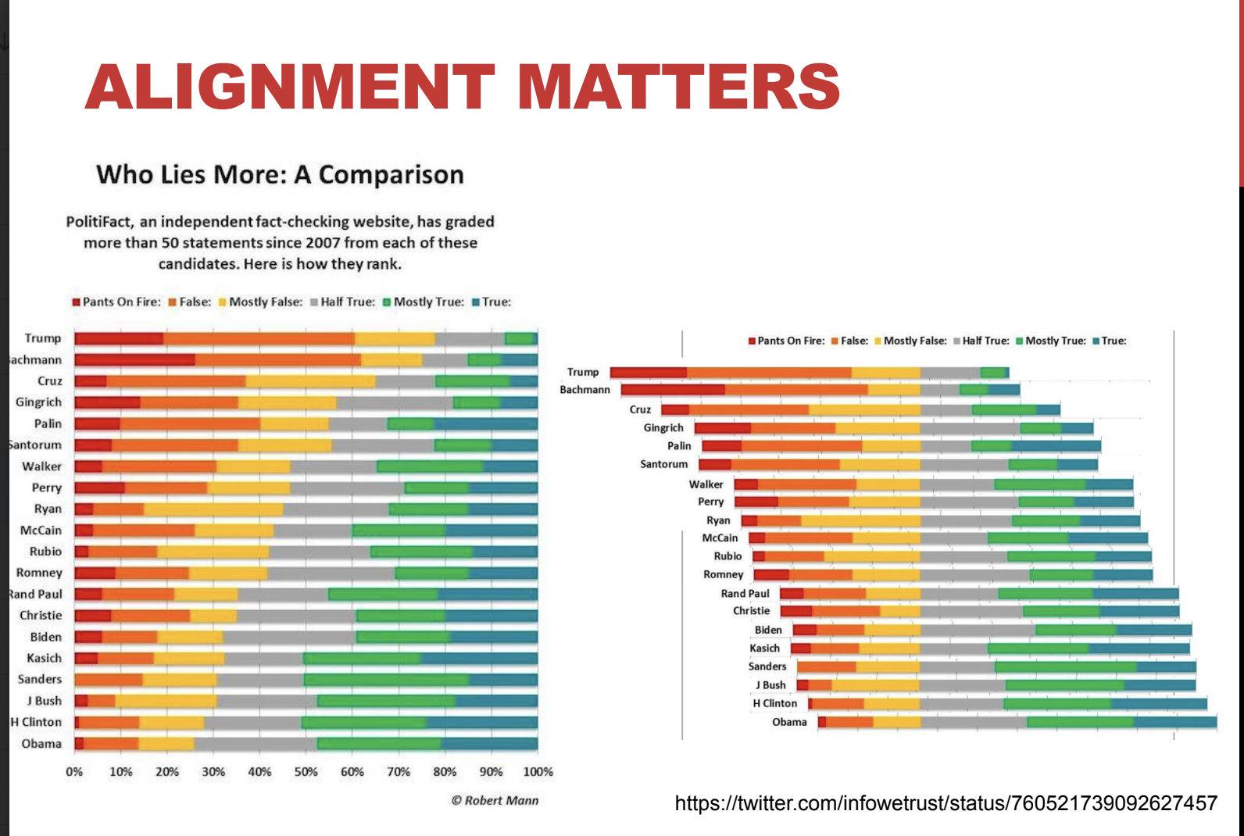

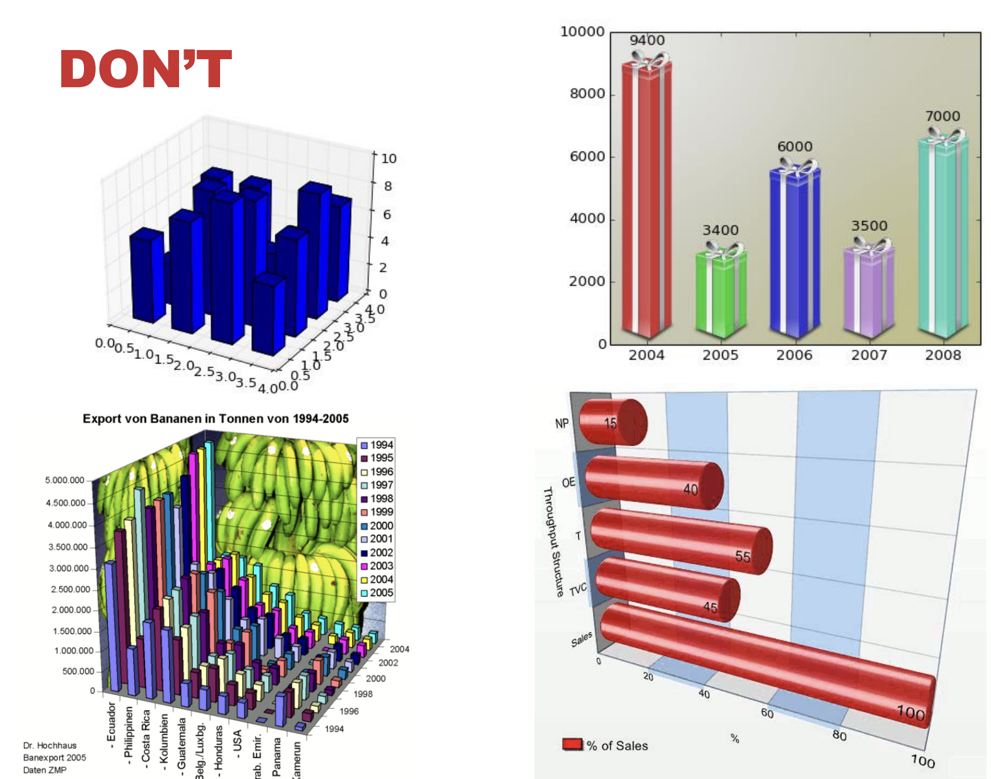

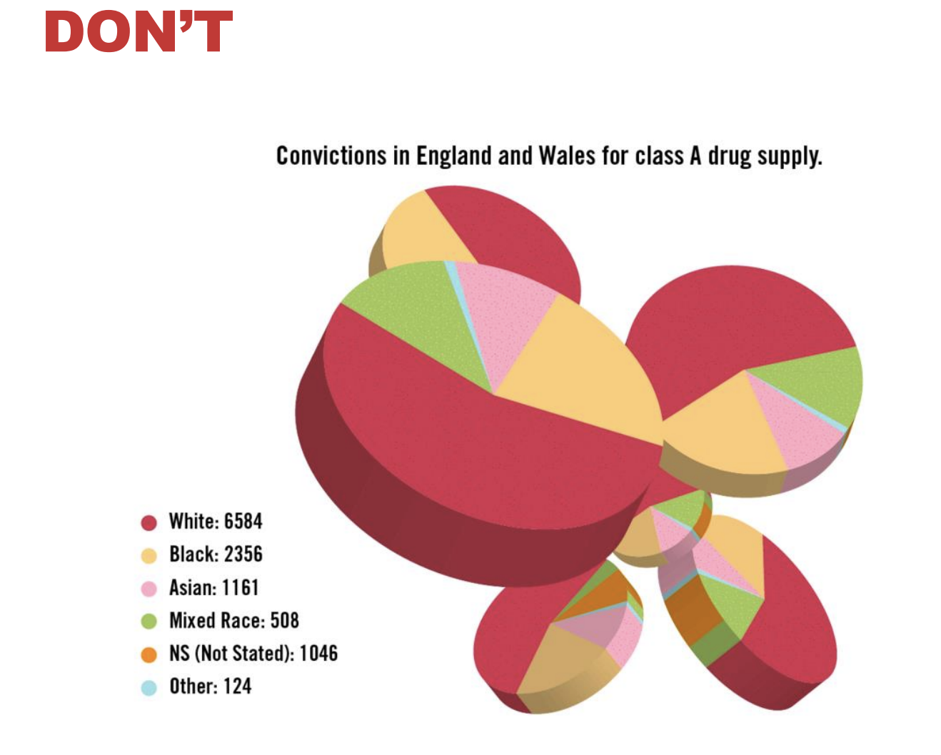

Alternative ways => try not to use 3D graphs in visualization because it is very hard to clarify for viewers to understand exactly the meaning of the graph.

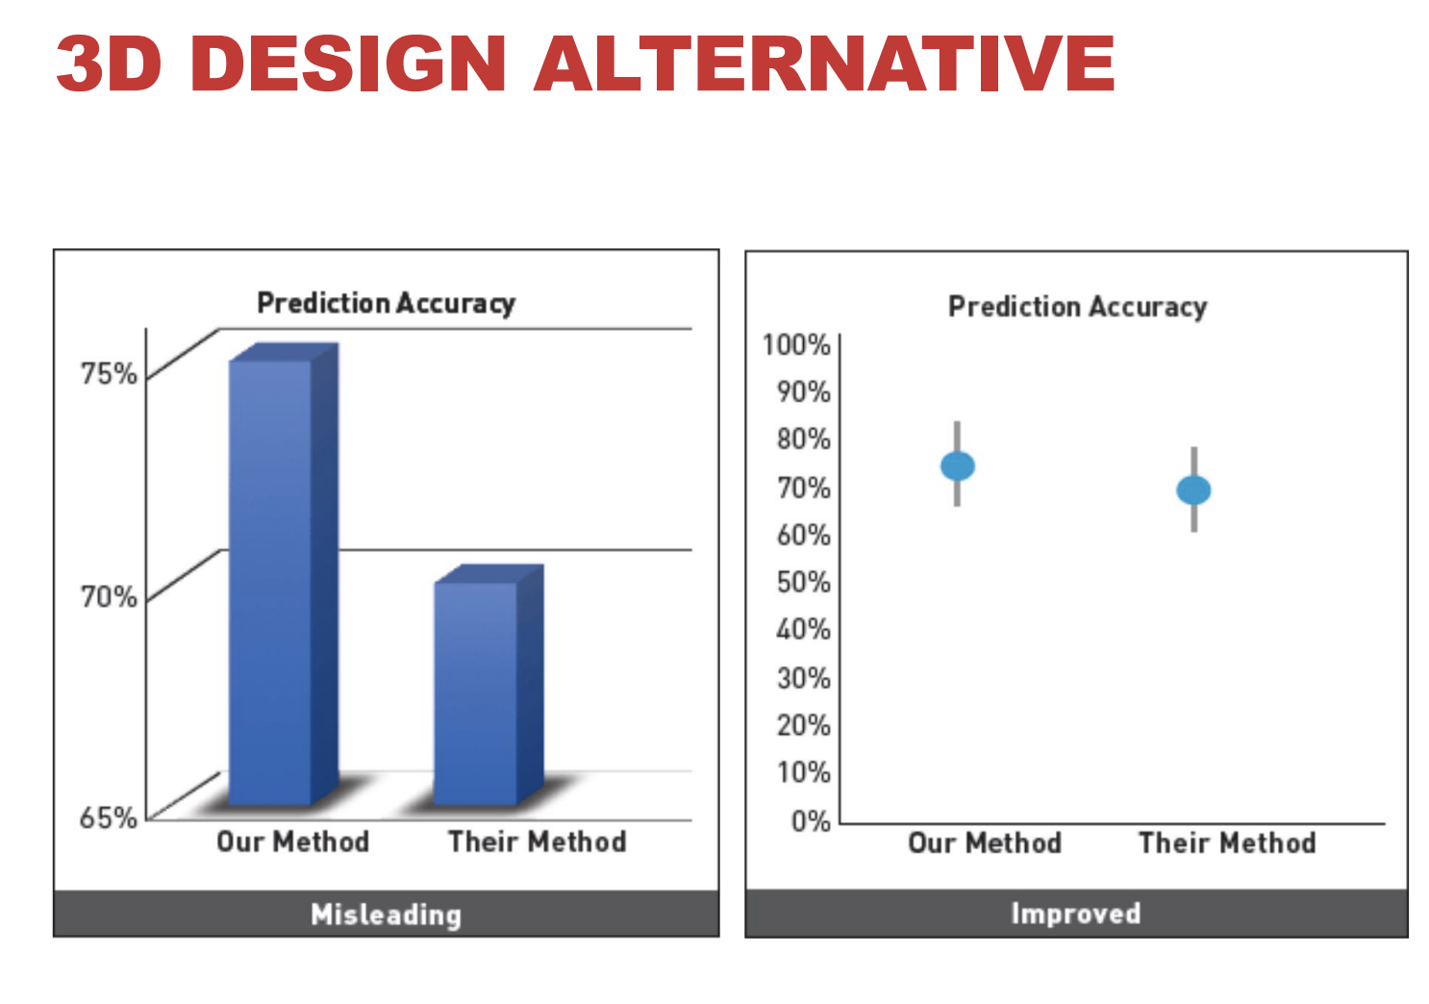

## **WHAT CAN WE DO DIFFERENTLY?**

* Eyes beat memory:
  + Small multiples
  + Simplify

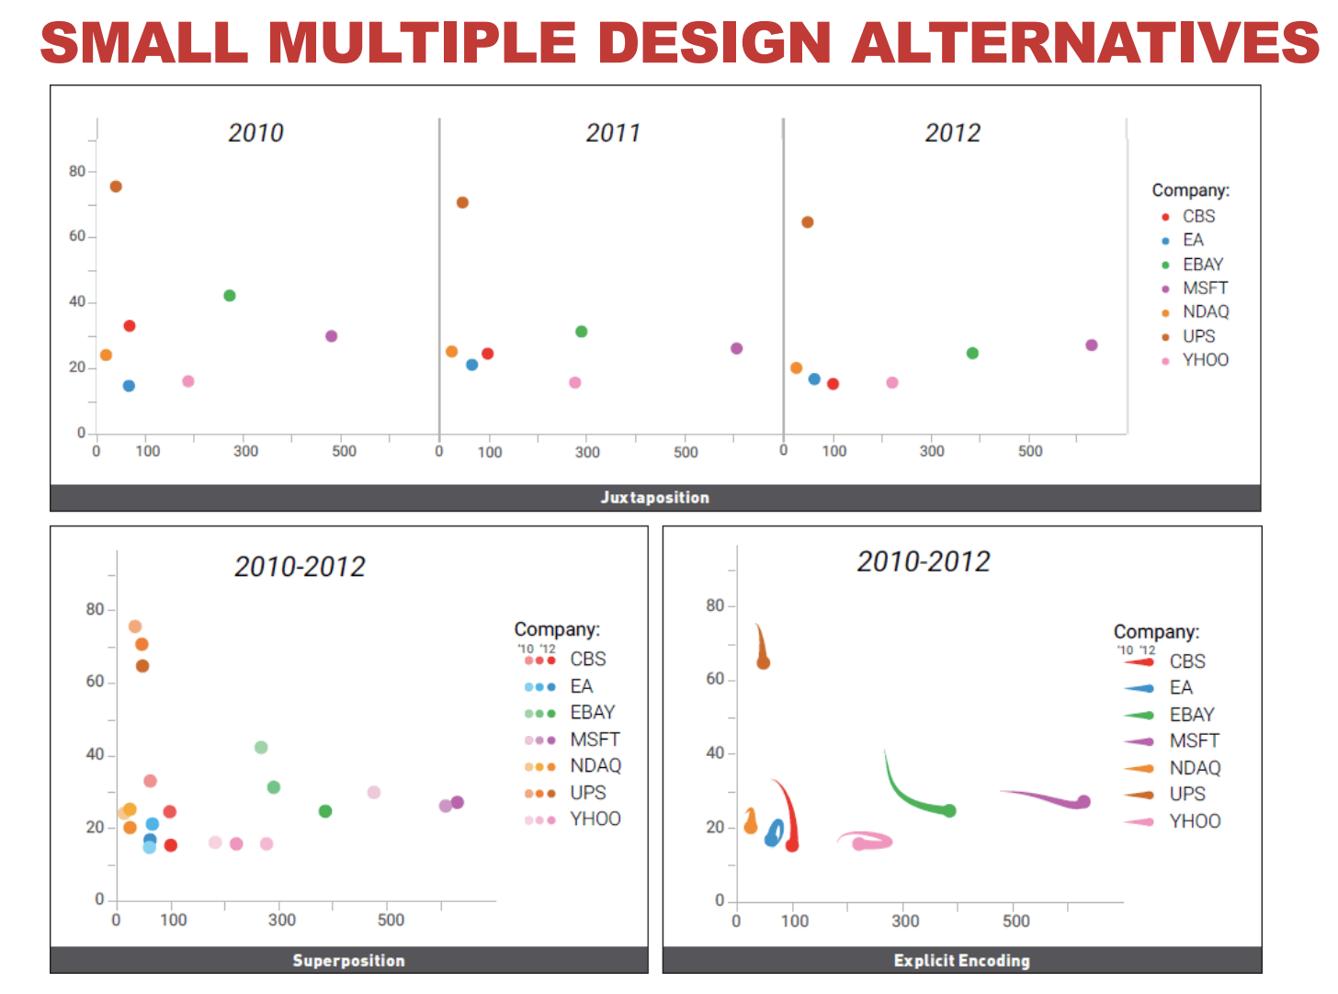

# **INTERACTION**

## **SPECTRUM**

| **Static content** | **Dynamic content** |
| --- | --- |
| Infographics (or figures) | 1. Animated content  * “Auto-play” 🡺user is not in control |
| Books | 1. Interactive content  * Changes are a result of user action |

* WHY INTERACT WITH VISUALIZARTION?
* Too much data cannot be shown in basic visualization.
* Too many ways to show it => Need to decompose and change the view such as decomposing it into many fields.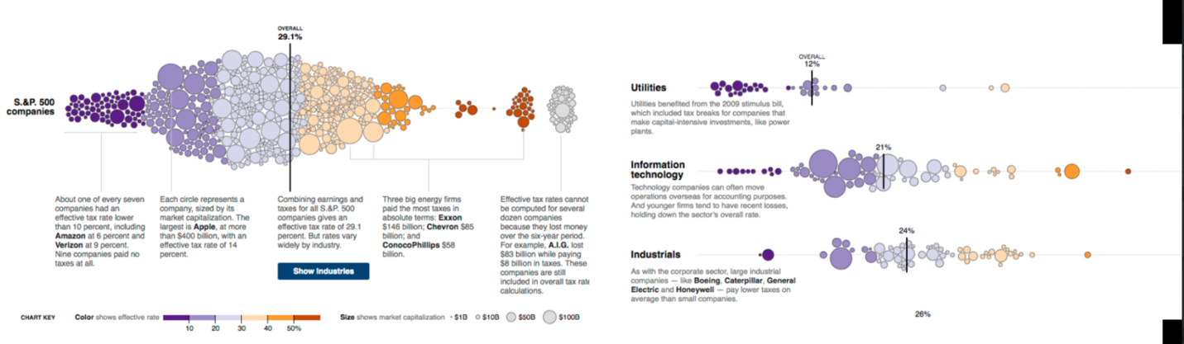
* WHY INTERACTION WITH VIS?
* Cause and effect such as GOOGLE MAP => by How long go to here?
* **Interaction amplifies (khuếch đại) cognition.** 
  + Understand better => if we can touch them.
  + When we can observe cause and effect (belong to data analysis).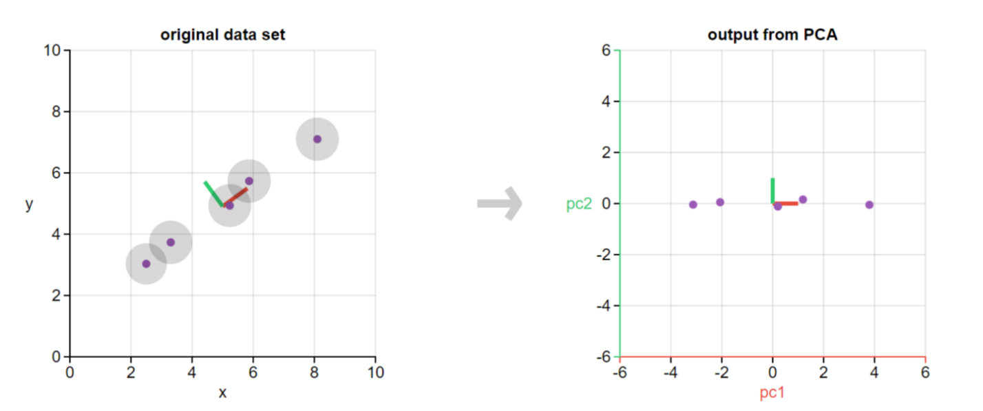
* INTERACTION METHODS

## Direct Manipulation

* Interact directly with objects => Continuous feedback/updates
* Indirect interact => Using a query, slides, etc.

## Types of interactions

| Single View  Change over time.  Navigation  Semantic zooming  Filtering and Querying  Focus + Context | Multiple View  Selection (Details on demand)  Linking & brushing  Adapting representation |
| --- | --- |
|  |

* Purpose of interaction => useful but quite complex to technology

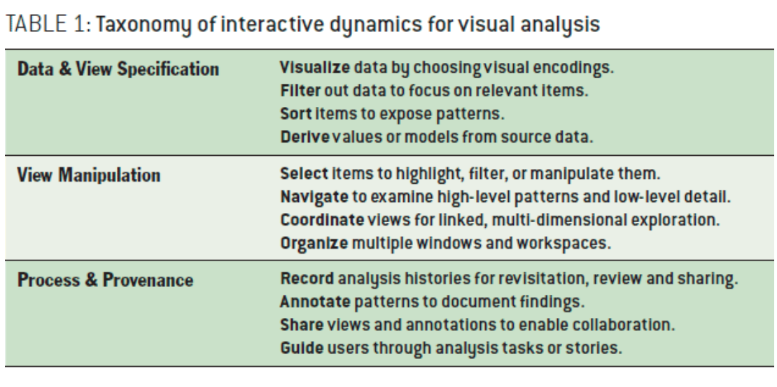

* Rule of thumb: responsive is required:
  + Visual feedback:
    - 0.1s: perceptual processing
    - 1s: immediate response
    - 10s: brief task => notify to user that you’re operating heavyweight => try to optimize the time response
  + Scalability: make new chart w/o redrawing the whole chart => save time
  + Cancel/undo feature:
    - Based on action/state (undo)
* All kinds of software to do these features.
  + Show progress bar: exactly know how many actions you do => estimate the time of each action.
  + Rendering speed: how can you make sure that dashboard run smoothly => based in different properties by depending on algorithm.
* Finally, to make sure that user has great experience which is have a great algorithm.

## CHANGE OVER TIME/TRANSITIONS

1. Change over time.

* Use slides => see view with data at different times
* Sometimes better => show difference explicitly (dứt khoác)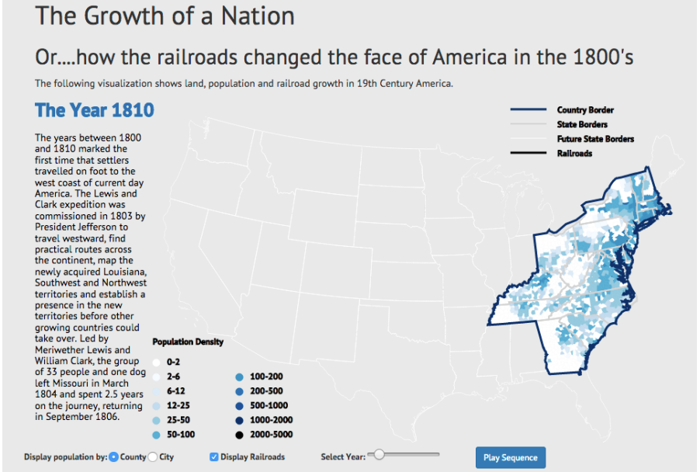

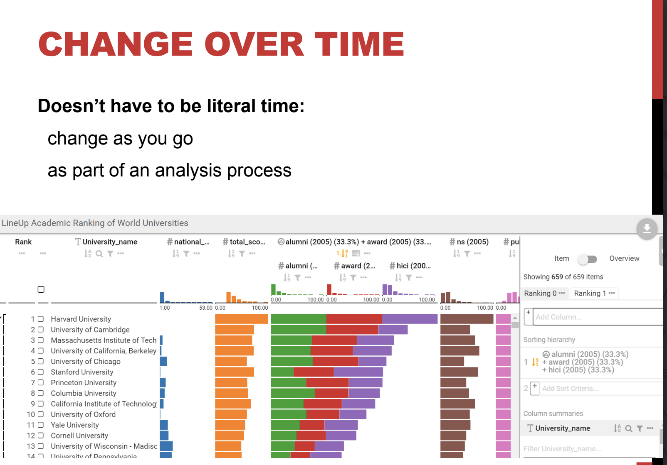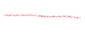

* WHY TRANSITION?
  + Different representations => support different tasks
  + Change ordering.
  + Transition help => user track what is going on
* Animated with transition in statical data graphics:
  + Trans(sorting) => help user keep track on the items.
  + Static: graph -> graph
  + Animation: change all of things
  + Staged animation: change step by step
* Animated transition -> smooth interpolation btw states or visualization techniques.
* Changes can be hard to track & eyes over memory which is quite limited memory.

## NAVIGATION

* Pan: moved around
* Zoom: Enlarge/ make smaller.
* Rotate

1. Scrolltelling

* Telling an interactive story
* Interaction by scrolling.
* Nice but
  + Continuous scrolling vs discrete states
  + Direct access
  + Unexpected behavior

## SEMANTIC ZOOMING

* Update content on zooming
* More detail as more space become available.
* Ideally readable at multiple resolutions

=> example: Google map.

## FOCUS + CONTEXT

* Carefully pick what to show.
* Hint at what you are not showing.
* Synthesis of visual encoding and interaction
  + User selects regions of interest (focus) through navigation or selection.
  + Provide context through:
    - Aggregation (sự tổng hợp)
    - Reduction (sự giảm bớt)
    - Layering (xếp lớp)
* ELISION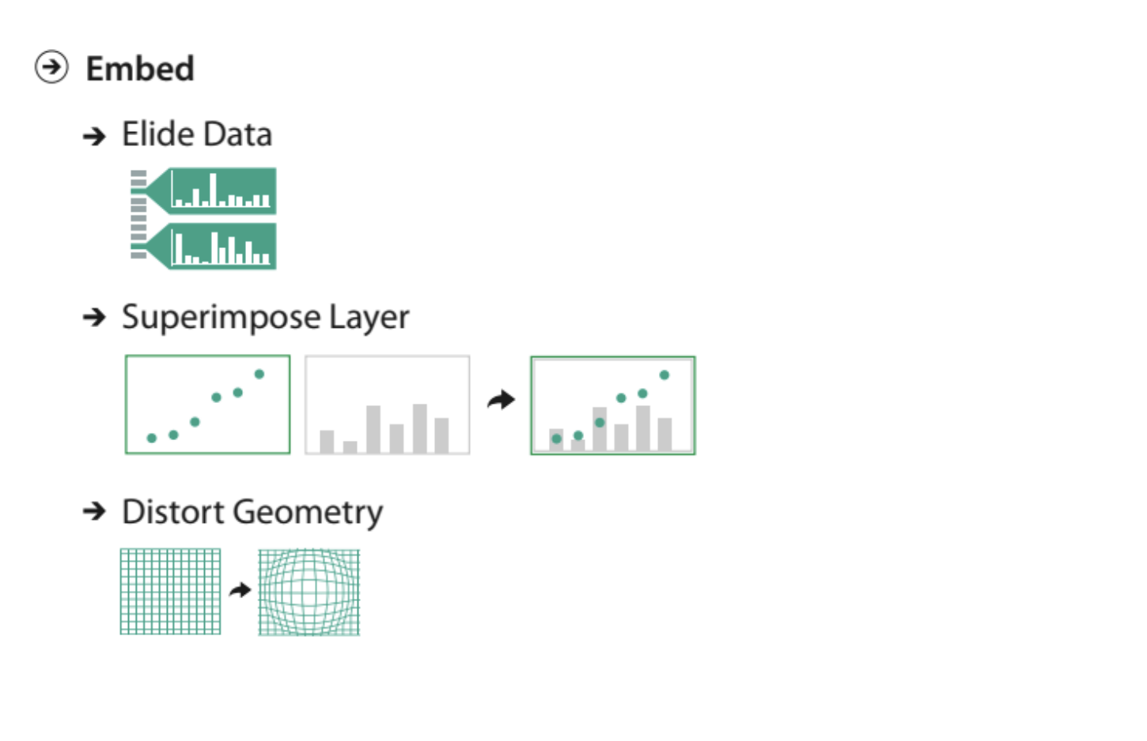
* Focus item shown in detail. => example: Space Tree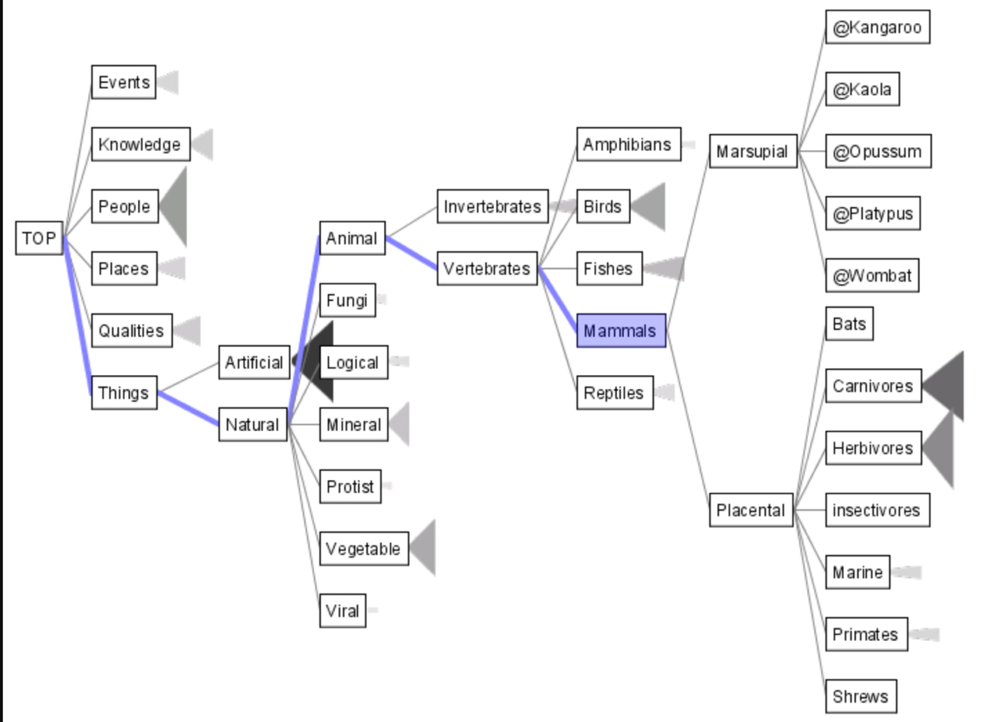

## DEGREE OF INTEREST (DOI)

* Represent objects in the neighborhood in detail, and only major landmarks far away.
* Balance between local detail and global context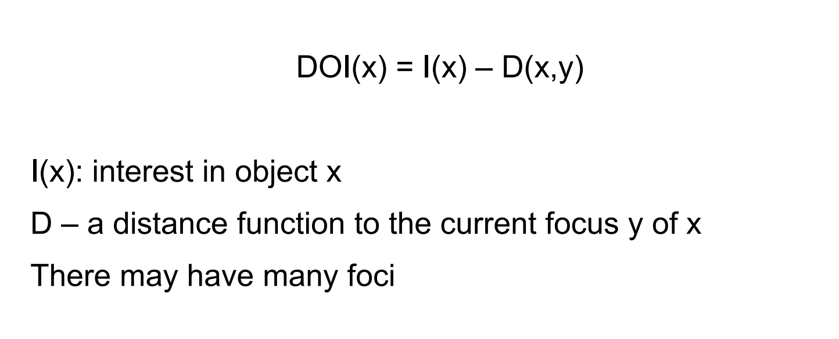

DOI TREE

* Interactive tree (cây tương tác) + animated transitions => fit within a bounded region of space layout depends on the user’s estimated DOI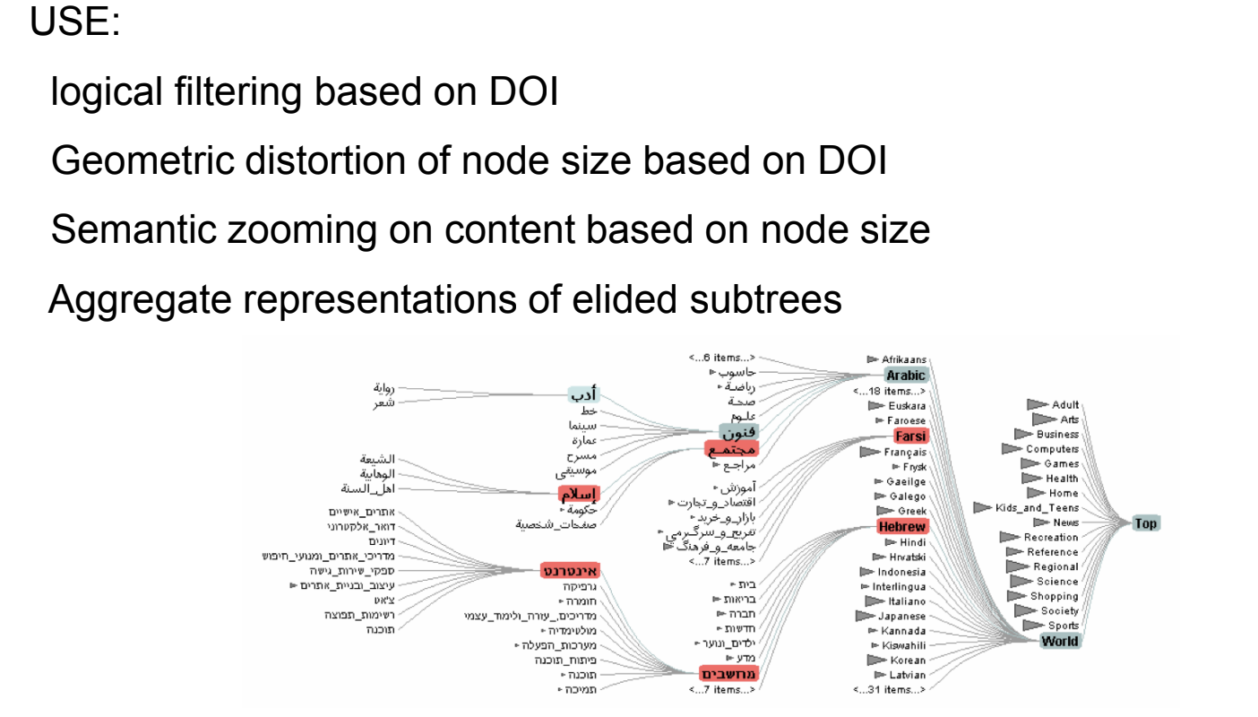

SUPERIMPOSE

Focus layer limited to a local region of view.

Instead of stretching across the entire view

TOOLGLASS & MAGIC LENSES

1. Magic lenses:

* Details/different data is shown when moving a lens over a scene.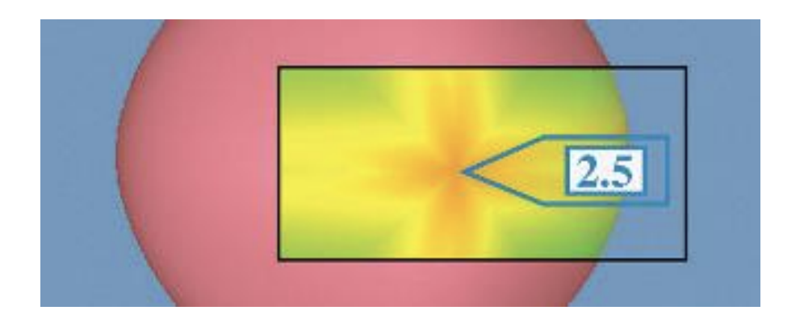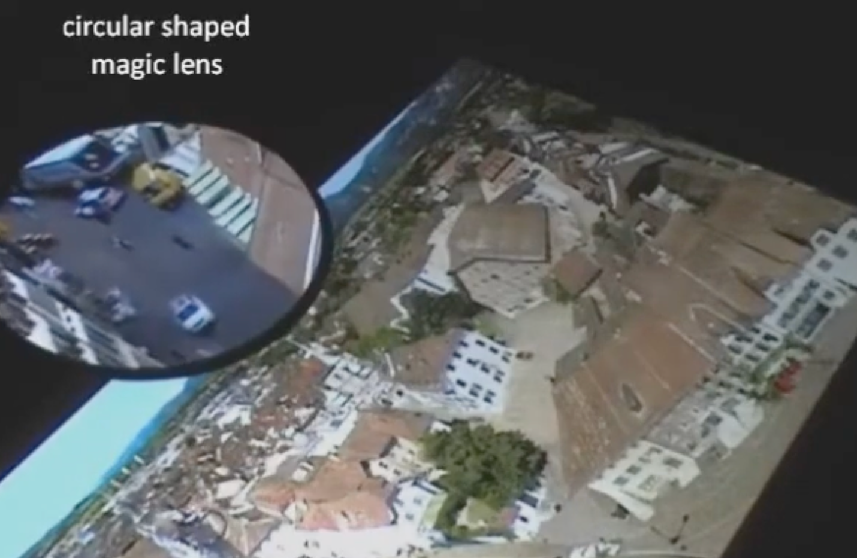

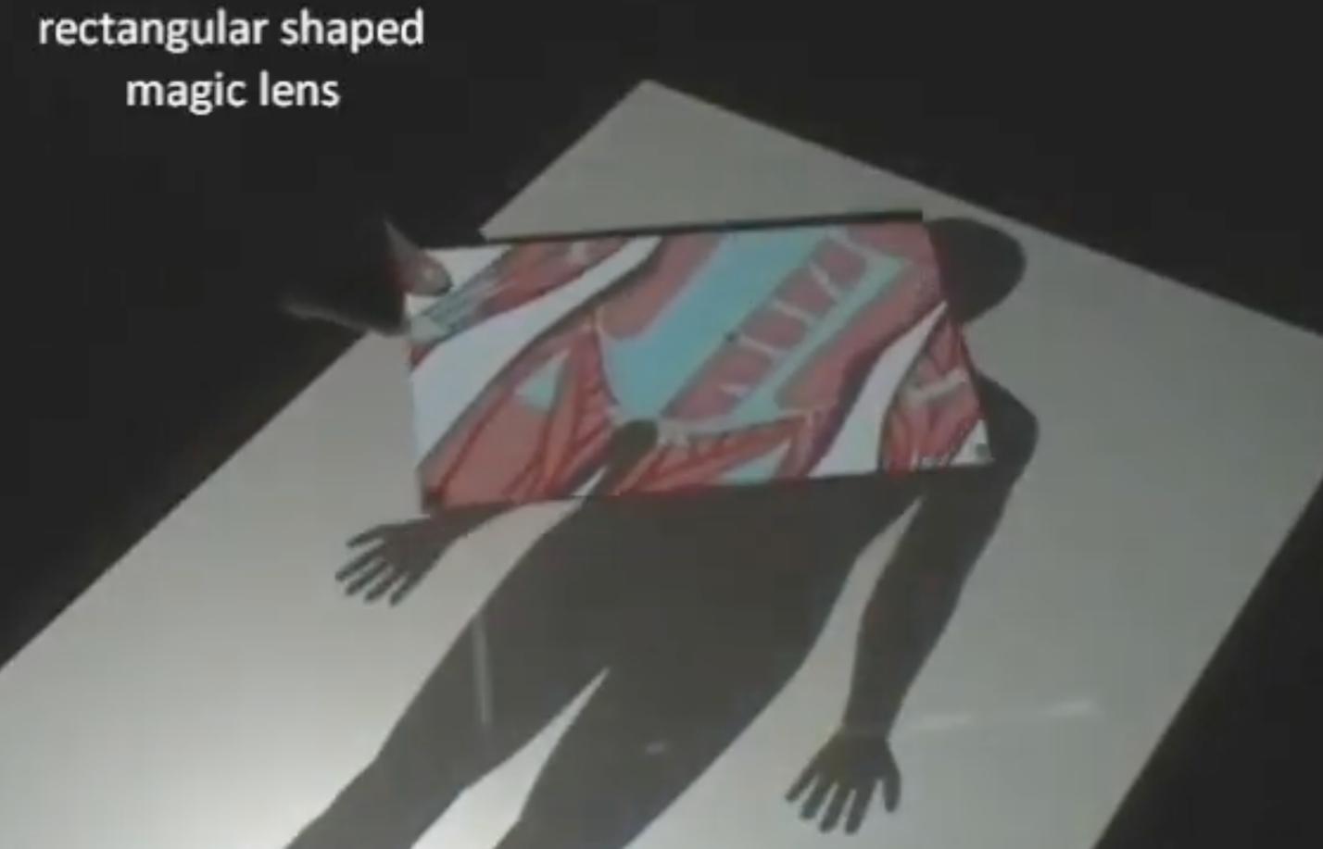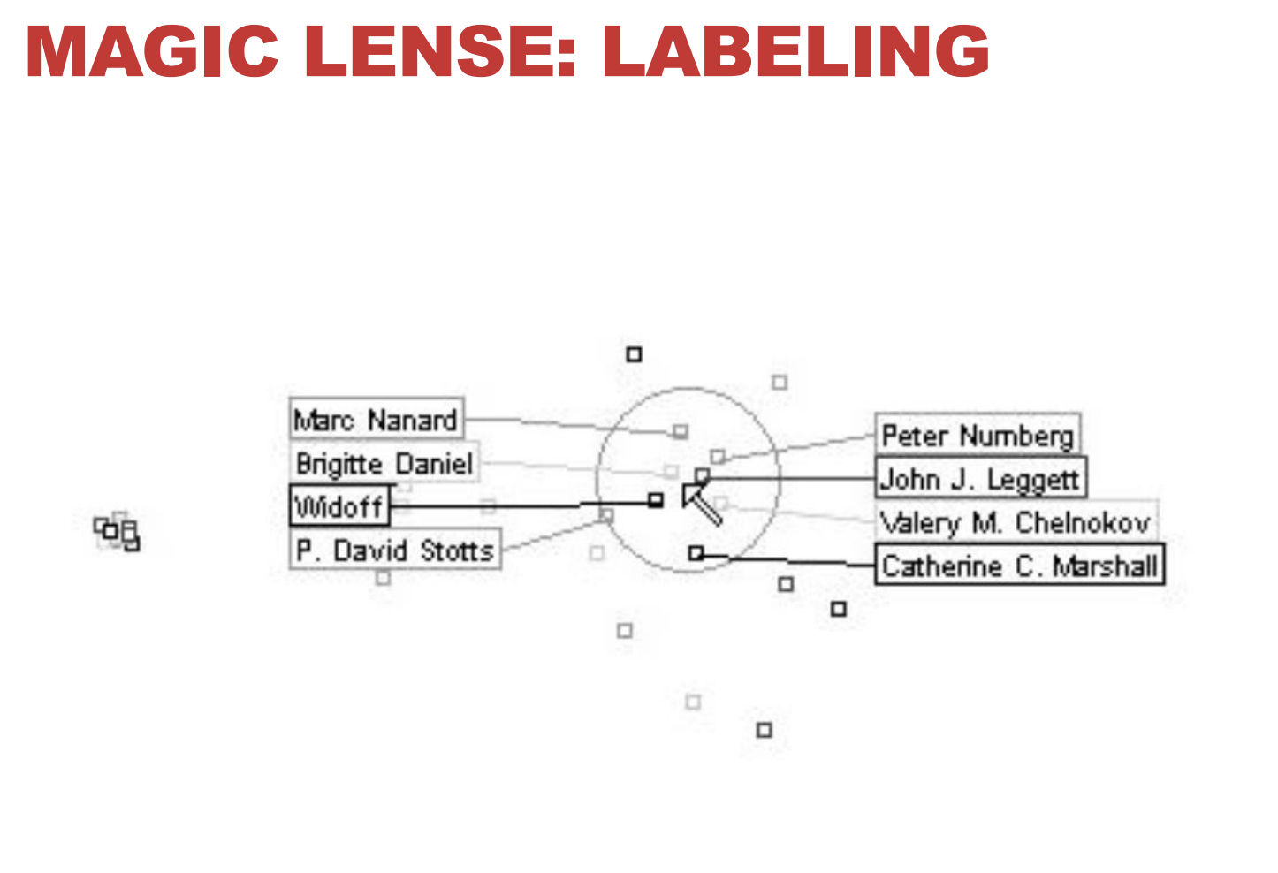

DISTORTION

* Use geometric distortion of the contextual regions to make room for the details in the focus region(s)

Example: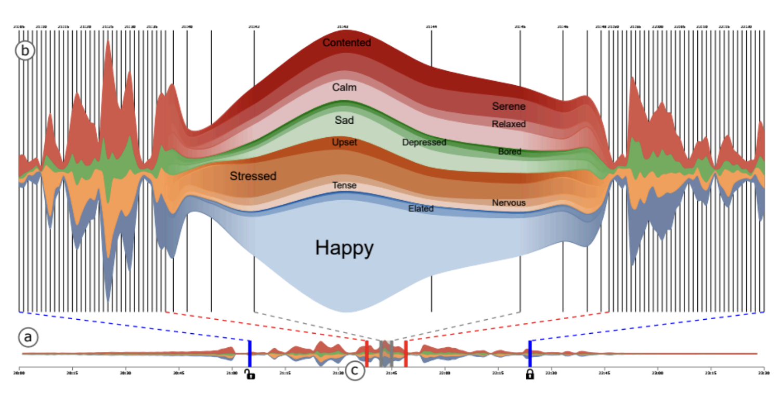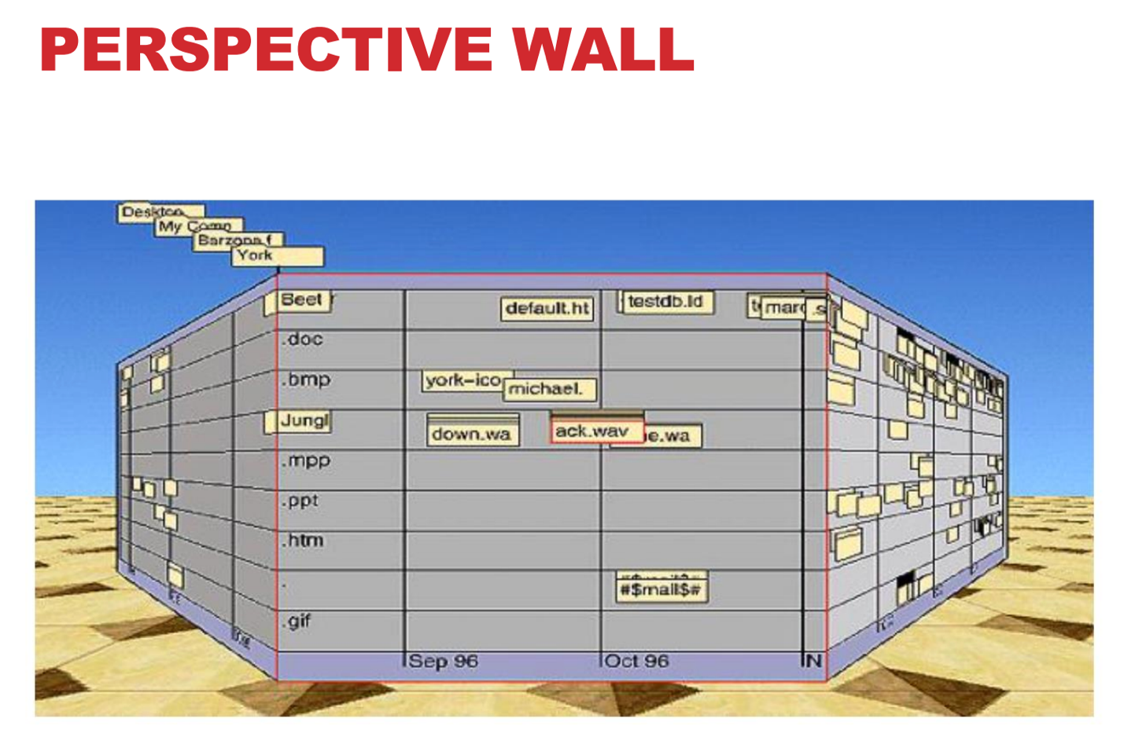

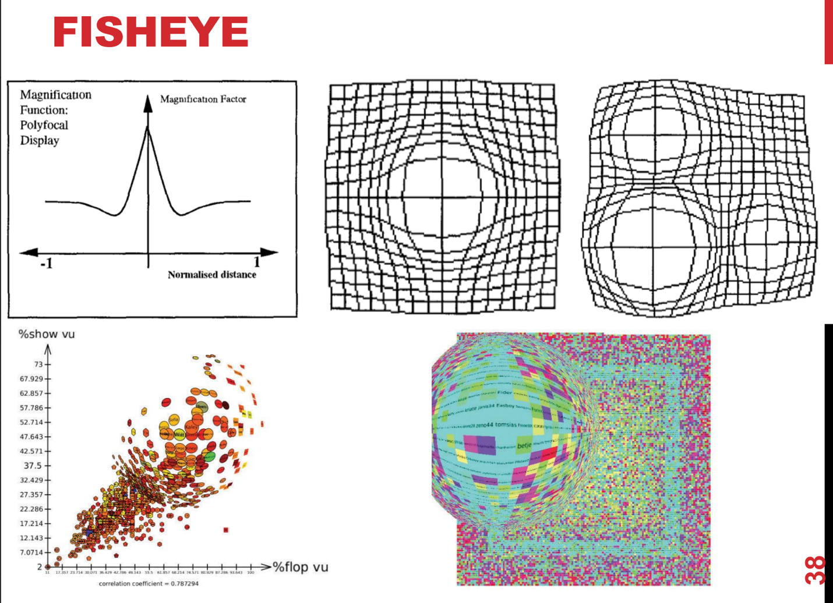

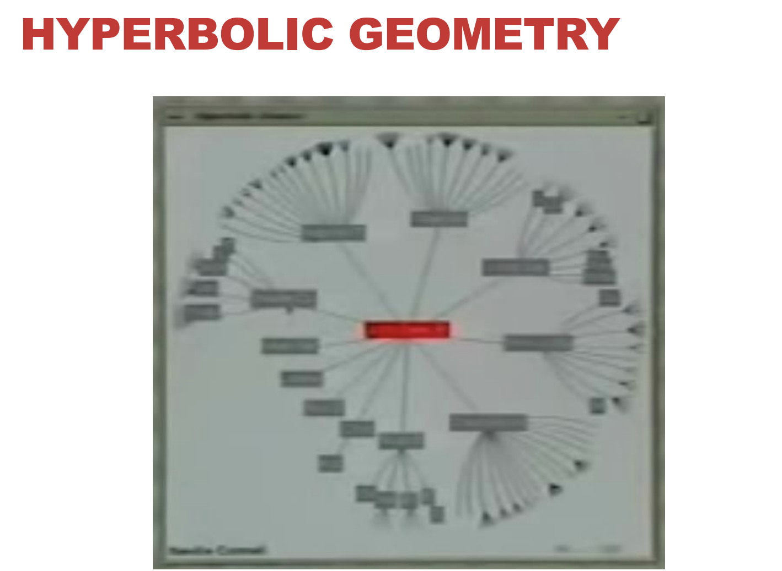

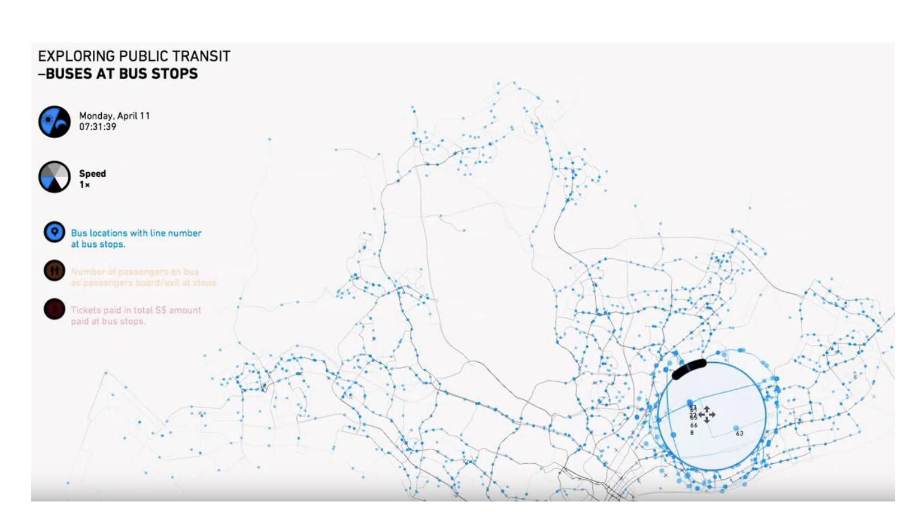

* Some concerns:
  + Unsuitable for relative spatial judgements
  + Overhead of tracking distortion
  + Visual communication of distortion gridlines (đường lưới biến dạng), shading.
  + Target acquisition problem lens displacing items away from screen location
  + Mixed result compared to separate views and temporal navigation (điều hướng tạm thời).

## OVERVIEW + DETAIL

* ***One view shows overview.***
* ***Other shows detail.***

## FILTERING & DYNAMIC QUERYING

1. Mantra
   * Overview first,
   * Zoom and filter,
   * Then details on demand.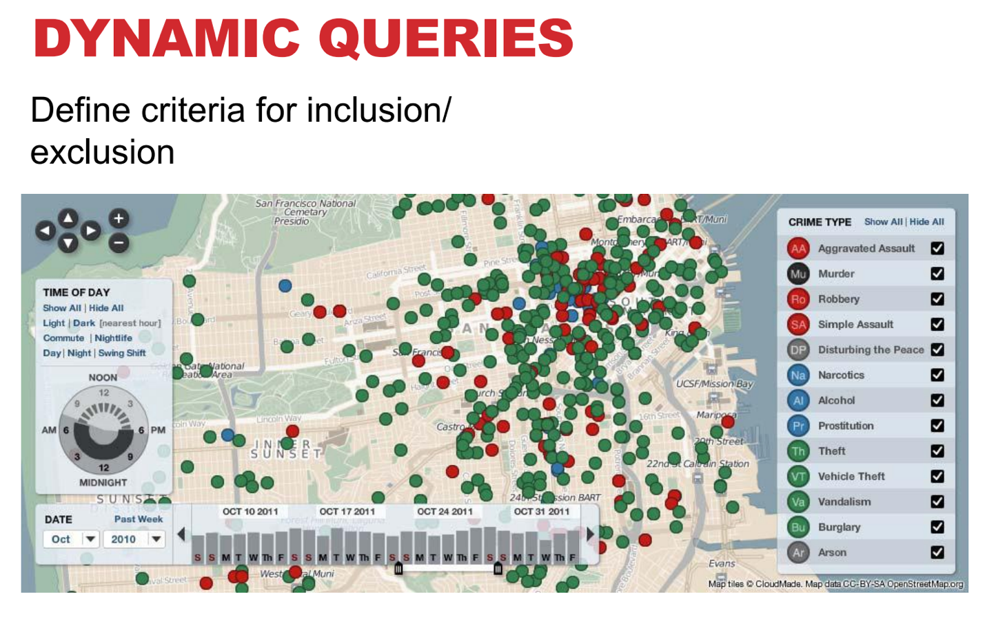

Inclusion (n): sự bao gồm

Exclusion (n): loại trừ

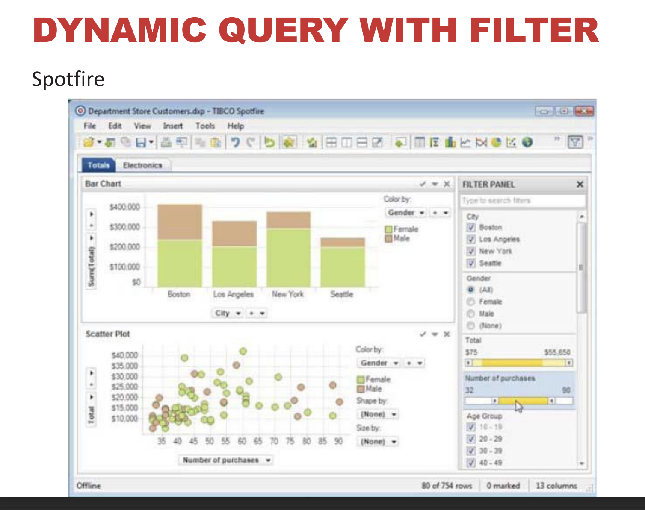

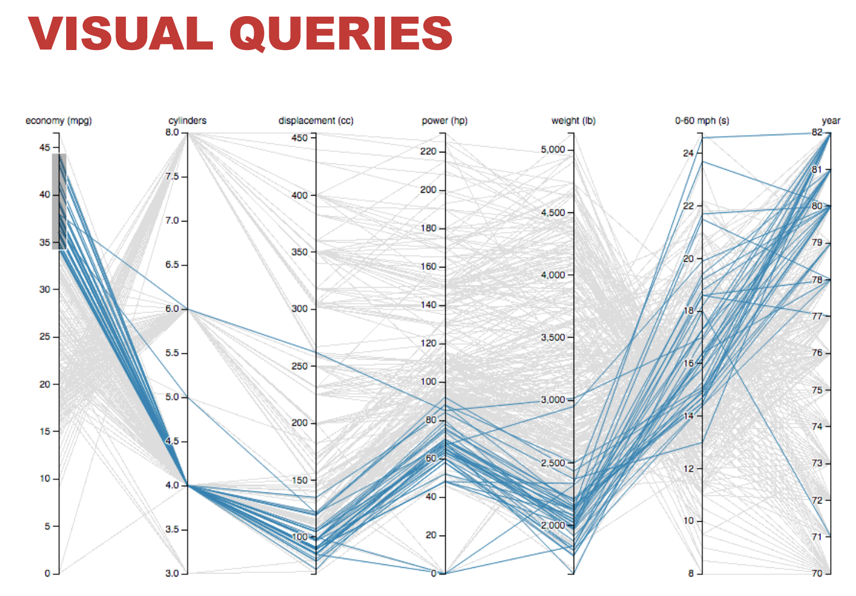

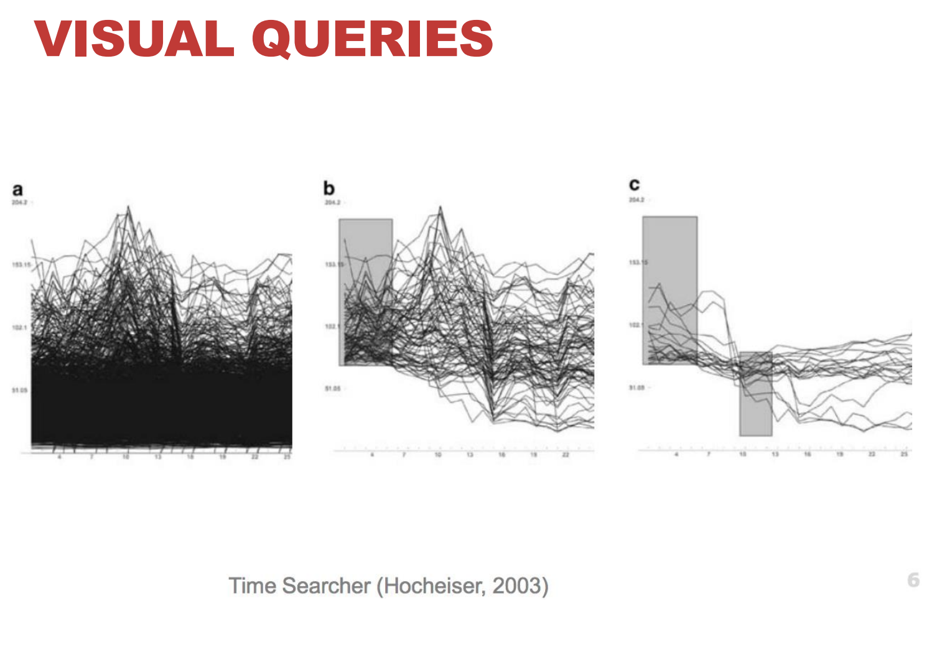

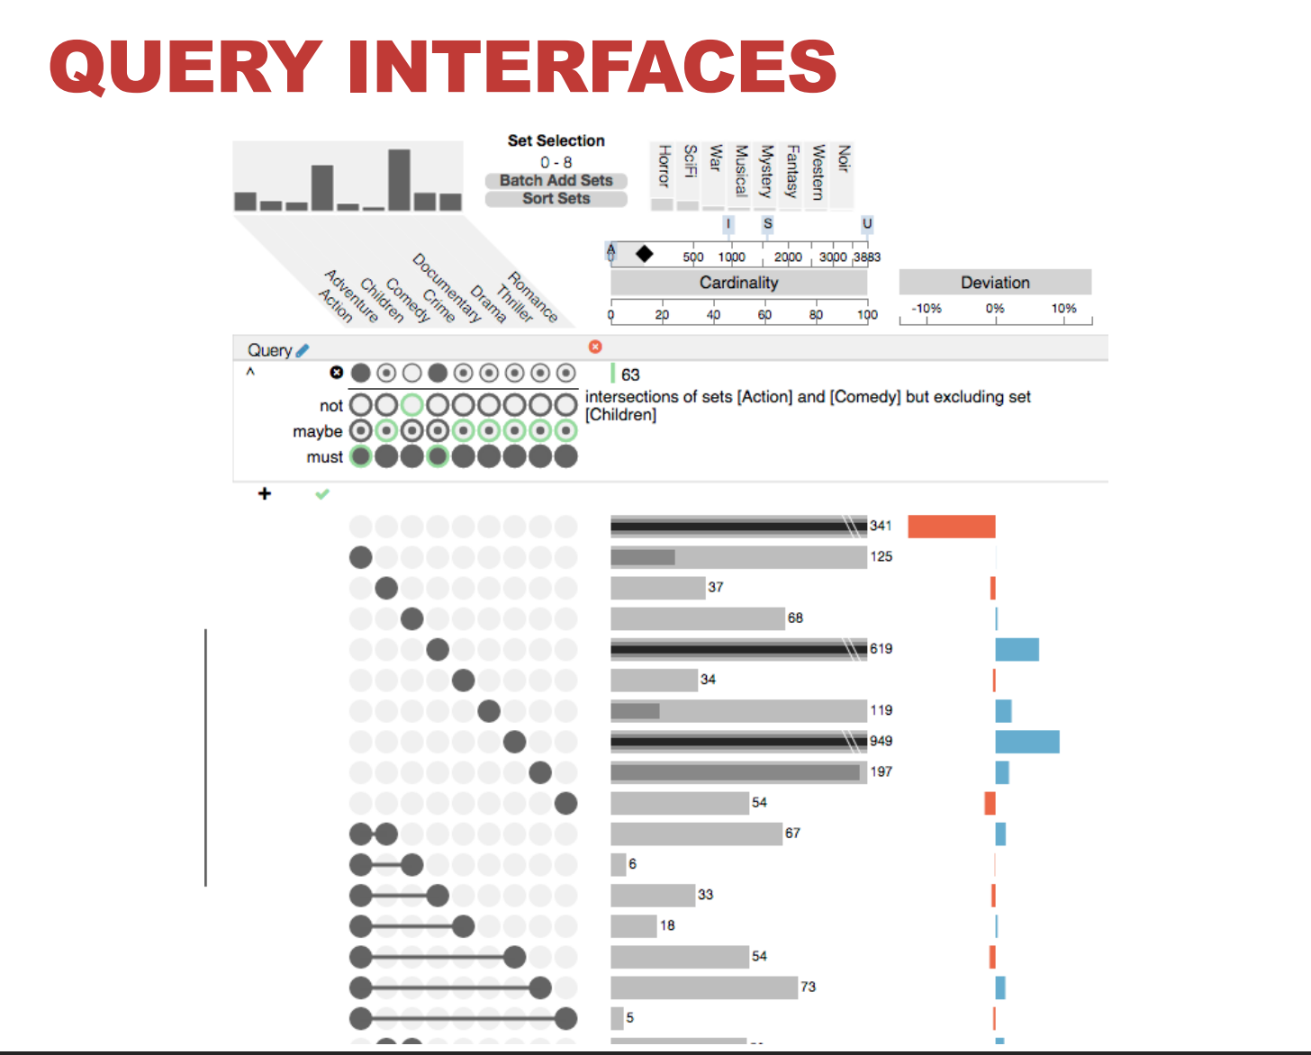

# **VIEW**

## **DESIGN CHOICES FOR MULTIPLE VIEWS**

* Dashboard is something to help people contact data and analyze it => for C level => show all possible to manage.
* Visualization help **user understand and analyze from raw data** to **model.**

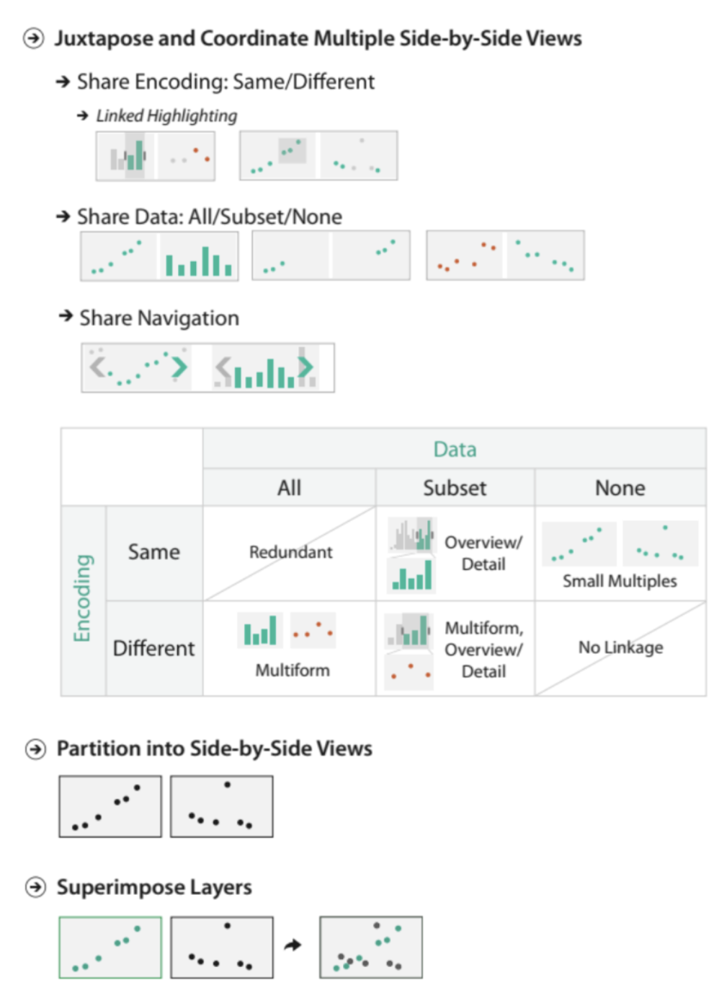

Eyes beat memory 🡺 showing two views side by side => to compare than changing over time.

No single visual encoding => optimal for all possible tasks (b/c use different encoding for one data).

Too many to shown in one view.

1. LINKED VIEWS (TECHNIQUE)

* Multiple views => visible and linked together
* Actions in one view => affect the others.
* Linked views options => just apply a few moment
  + Four options:
    - Highlighting: to link, or not
    - Navigation: to share, or not
    - Encoding: same or multiform
    - Dataset: shared all, subset, or none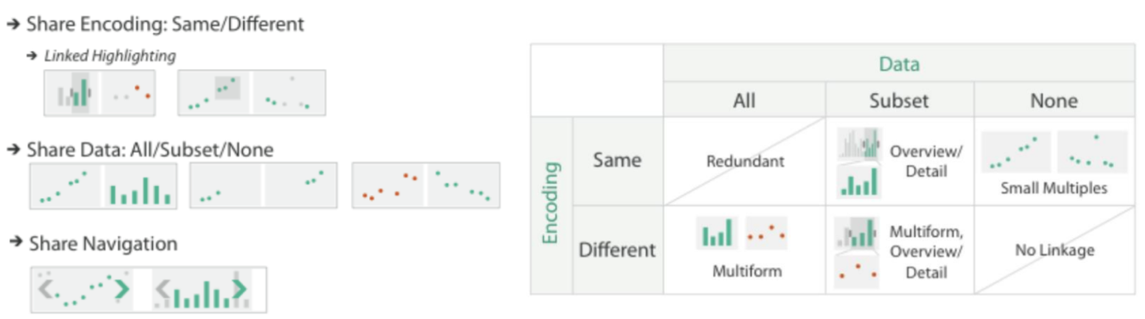



## **MULTIFORM**

* Different visual encoding used => shared data: either all data, or subset of data (overview + detail)
* Rational: Single view => strong limits on the number of attributes => shown simultaneously.
* Different views => support different tasks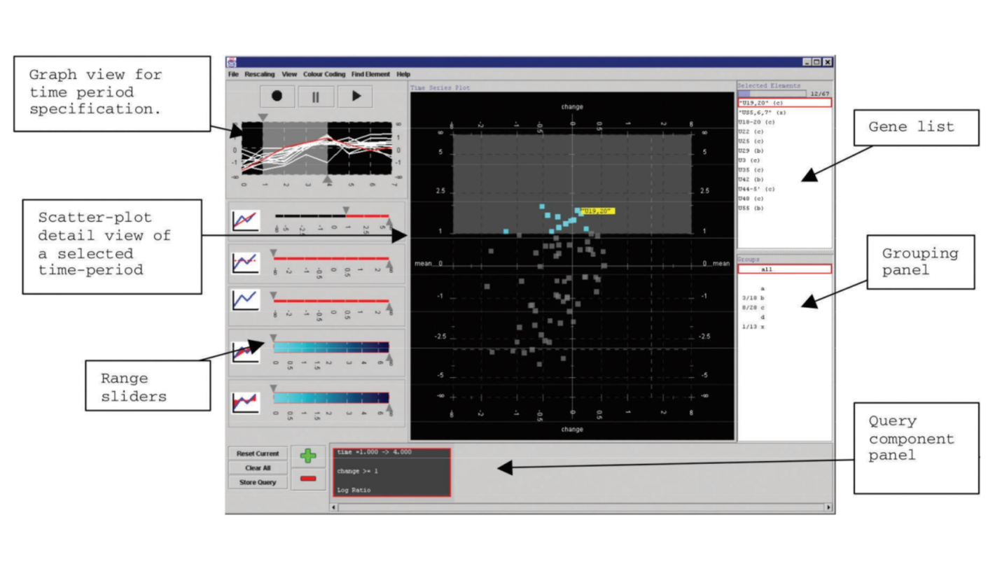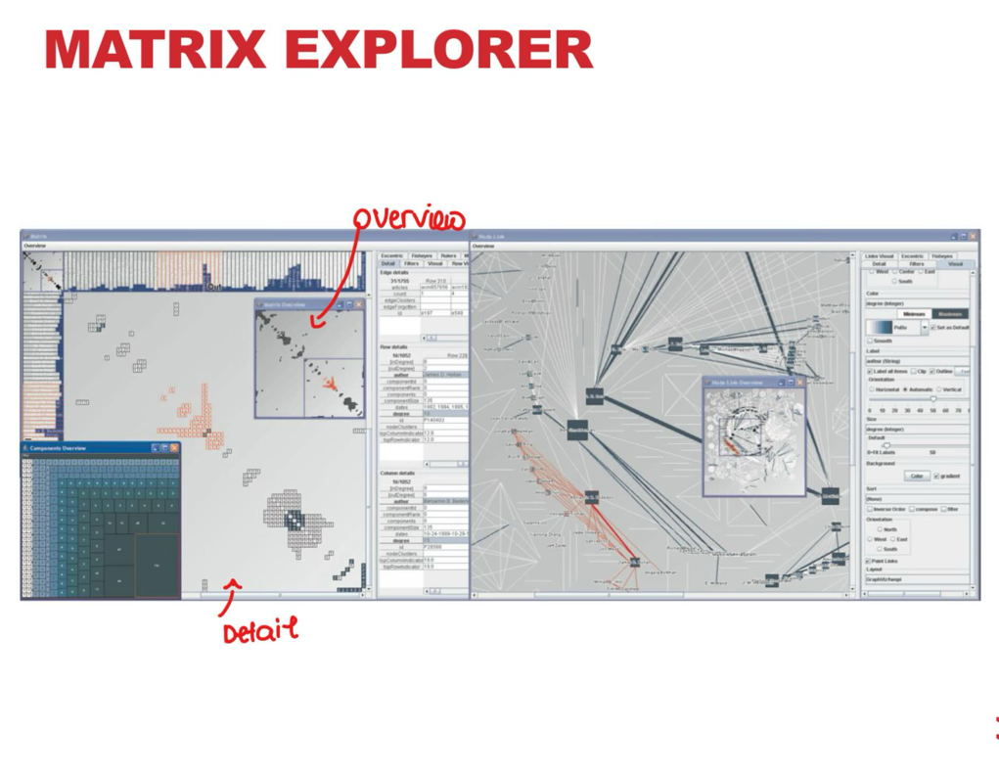

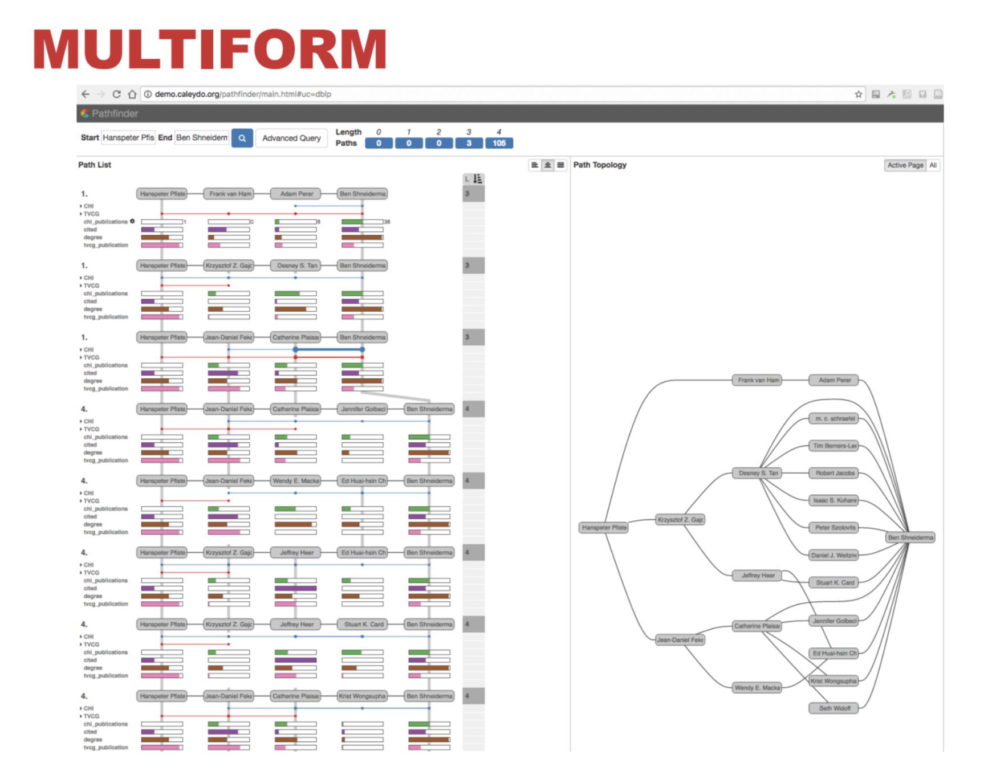

OVERVIEW + DETAIL

* One view 🡺 often summarized info about entire dataset.
* Additional view(s) => shows more details info about a subset of the data
* Rational:
  + For large or complex data => a single view of the entire dataset

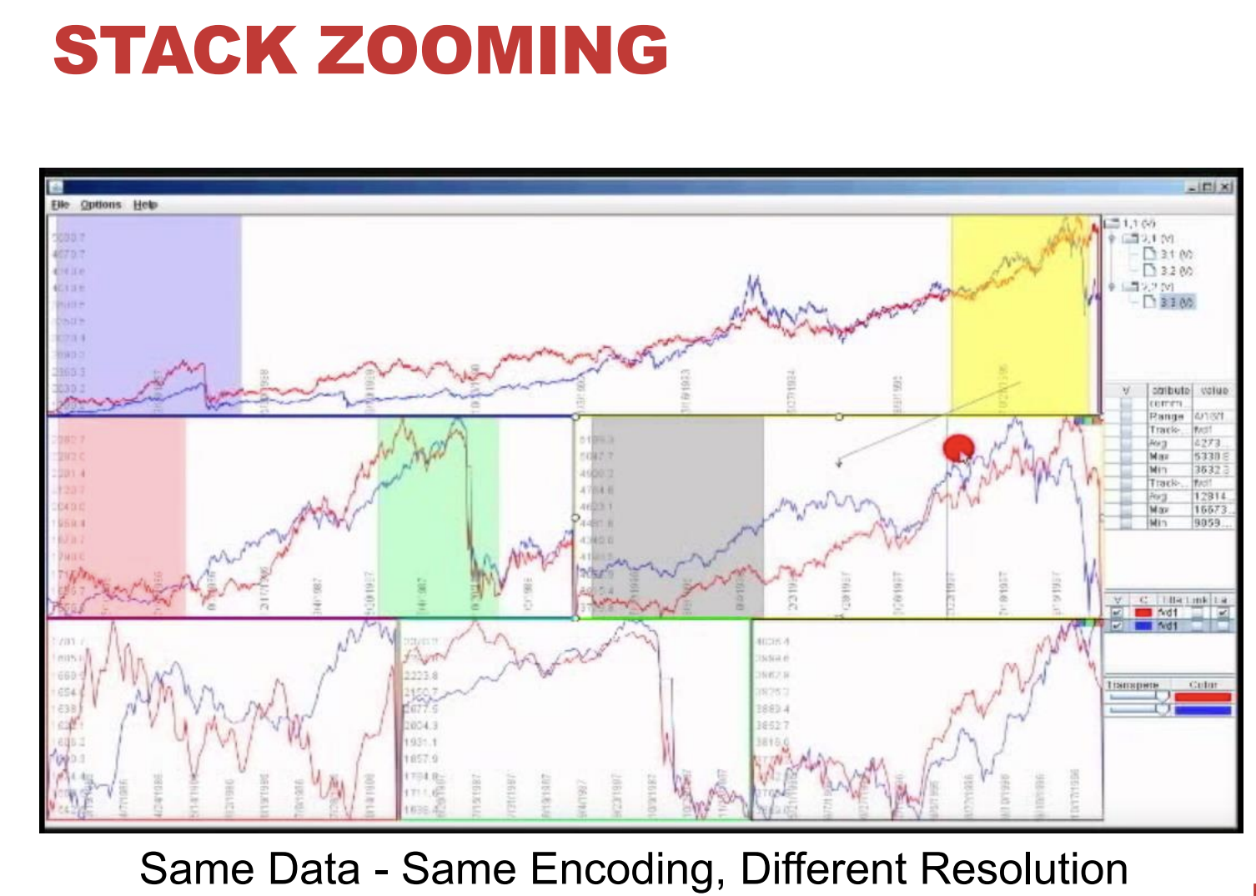

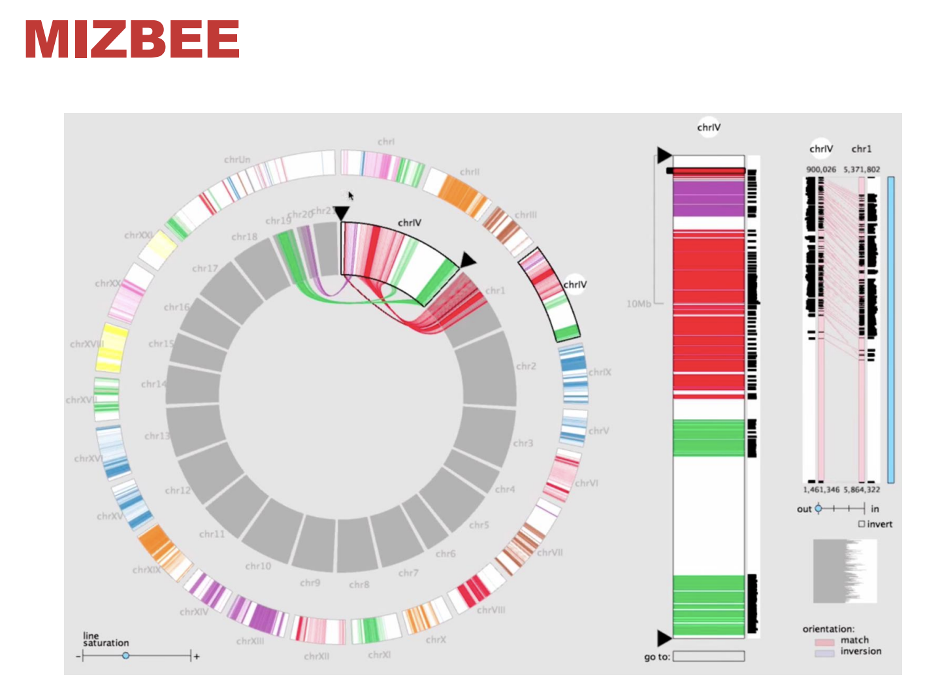

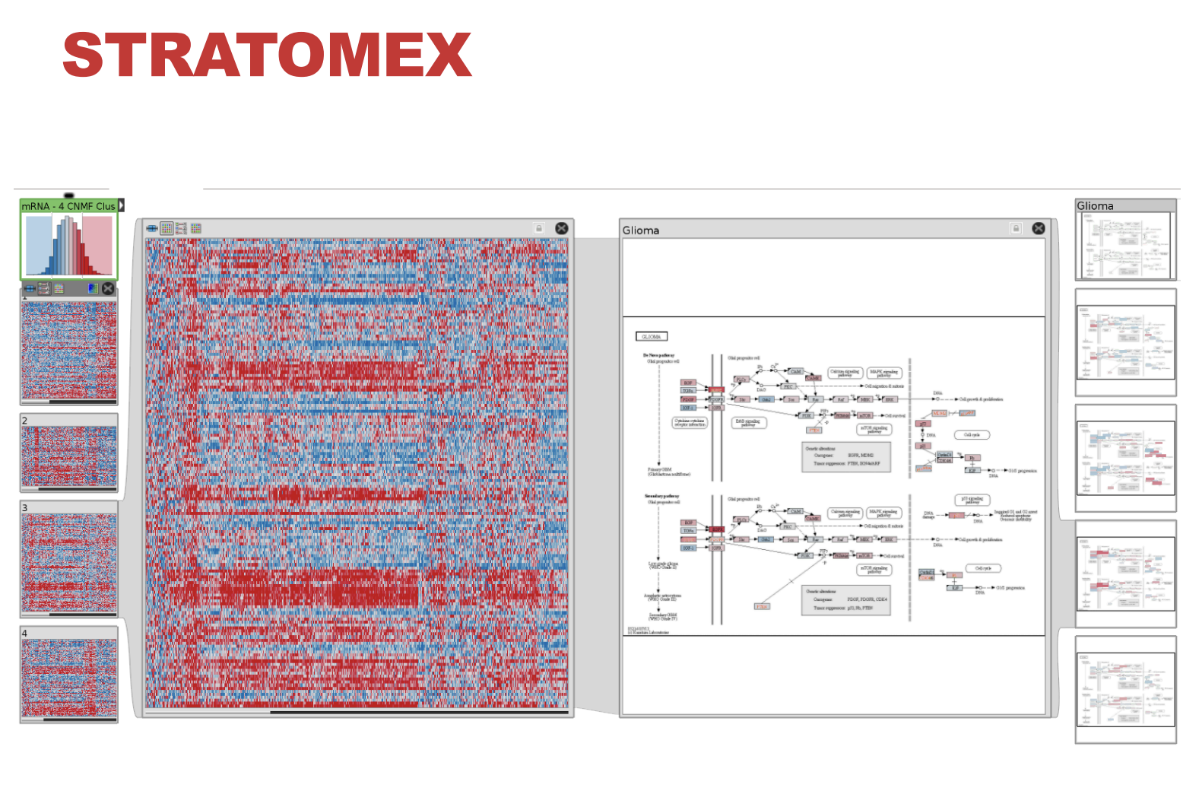

* Multipleview – need expert to design better view for user.

## **SMALL MULTIPLES**

* Each view uses the same visual encoding but shows a different subset of the data.
* Rational: compare different parts of a dataset very fast => relying on eyes instead of memory.

## **PARTITIONING**

* Actions on the dataset => separates the data into groups
* Design choices:
  + How to divide data up between views => given a hierarchy of attributes.
  + How many splits, and order of splits.
  + How many views (usually data driven)

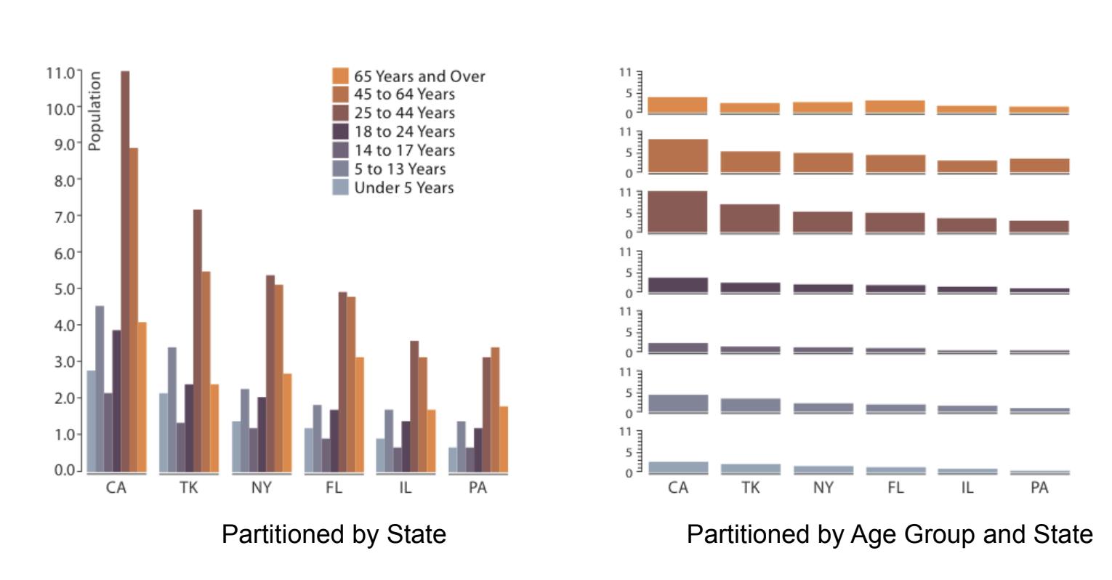

* Different views -> different recognition
* Scatter plot has problem with overlapping -> partition will help to solve this

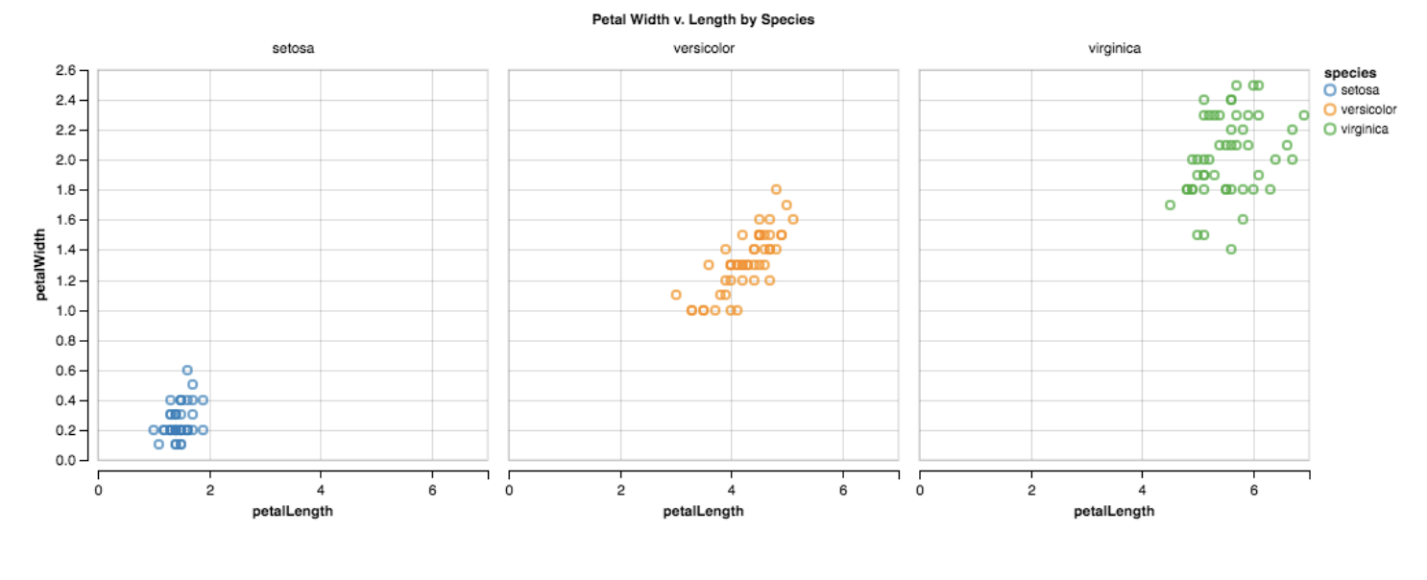

* Overlapping problems by put it multipleview.

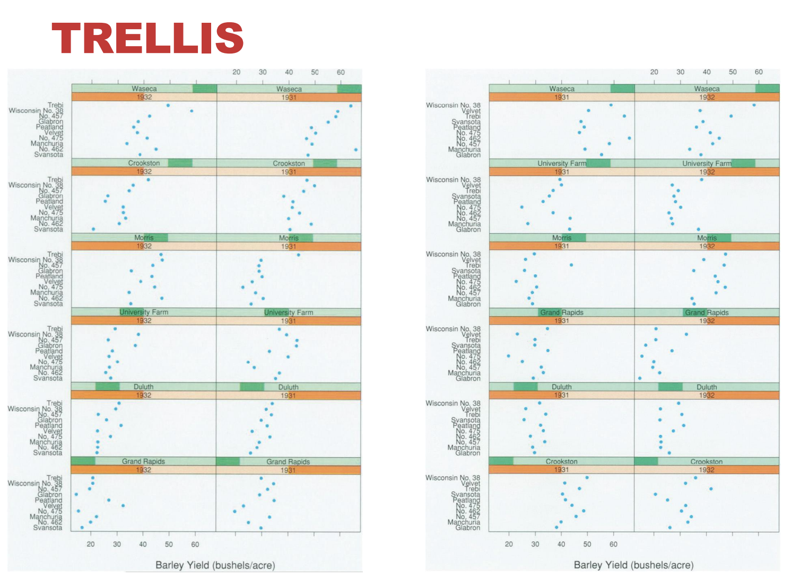

## **TRELLIS PLOTS**

* Panel variables
  + Attributes encoded individual views.
* Partitioning variables
  + Partitioning attributes assigned to columns and rows.
* Main-effects ordering
  + Order partitioning variable based on derived data.
  + Support perception of trends and structure in data.

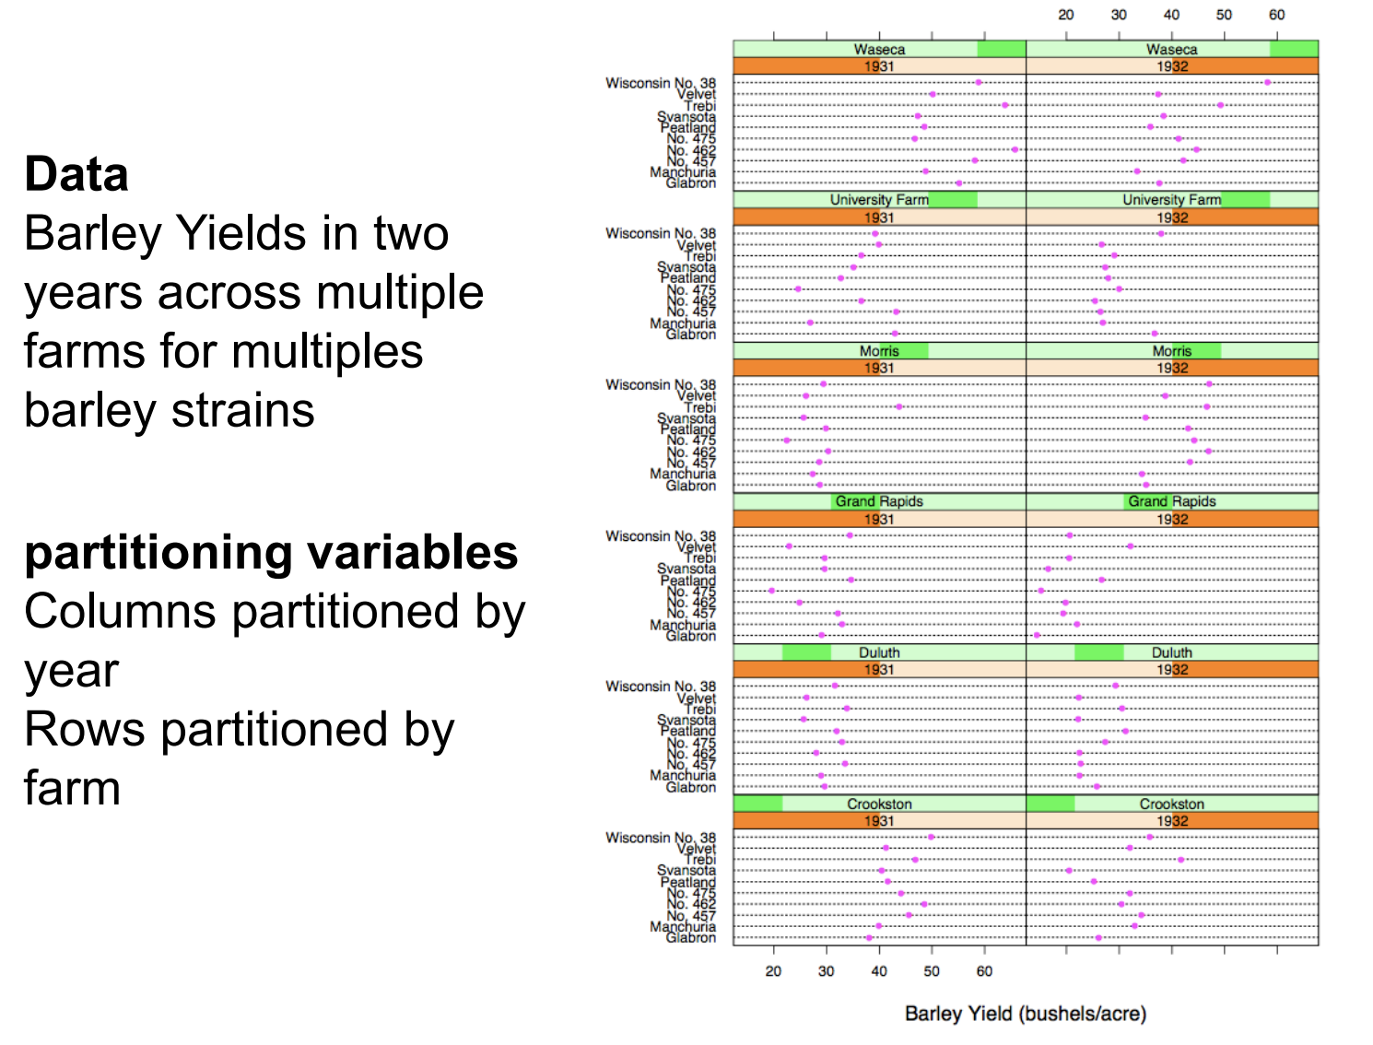

**🡺 hard to detect.**

## RECURSIVE SUBDIVISION

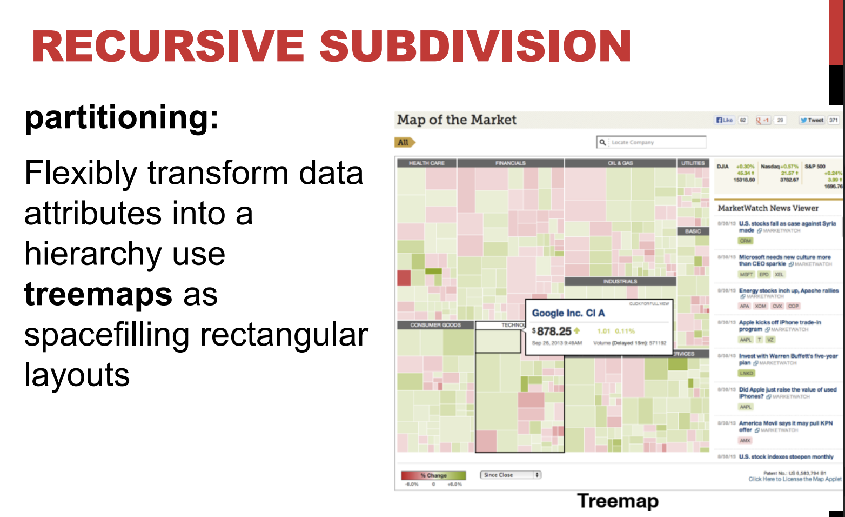



* Don’t make it too much => hard to understand and analyze

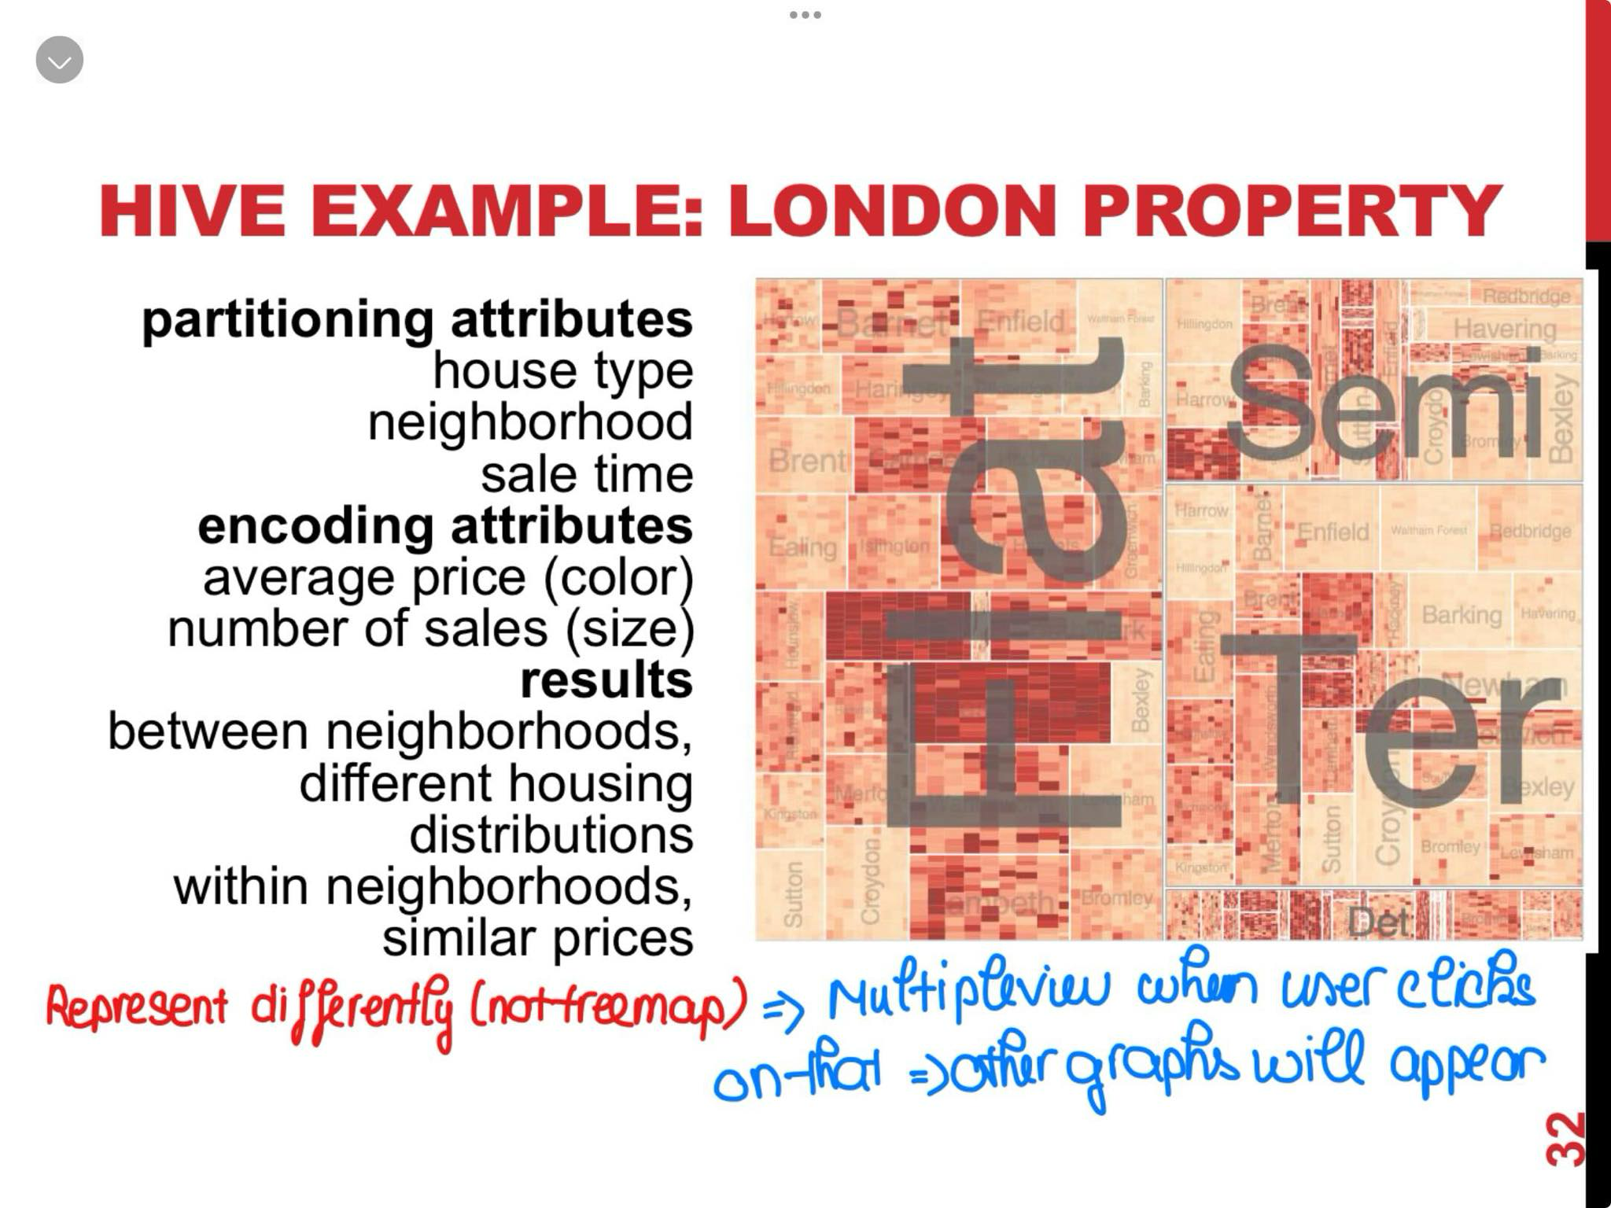

## **LAYERING**

Combining multiple views on top of one another

To form a composite view

Rational:

* Supports a larger, more detailed using multiple views

Trade-off:

* Layering imposes constraints on visual encoding choice + number of layers that can be shown.

## SUPERIMPOSED VS JUXTAPOSED

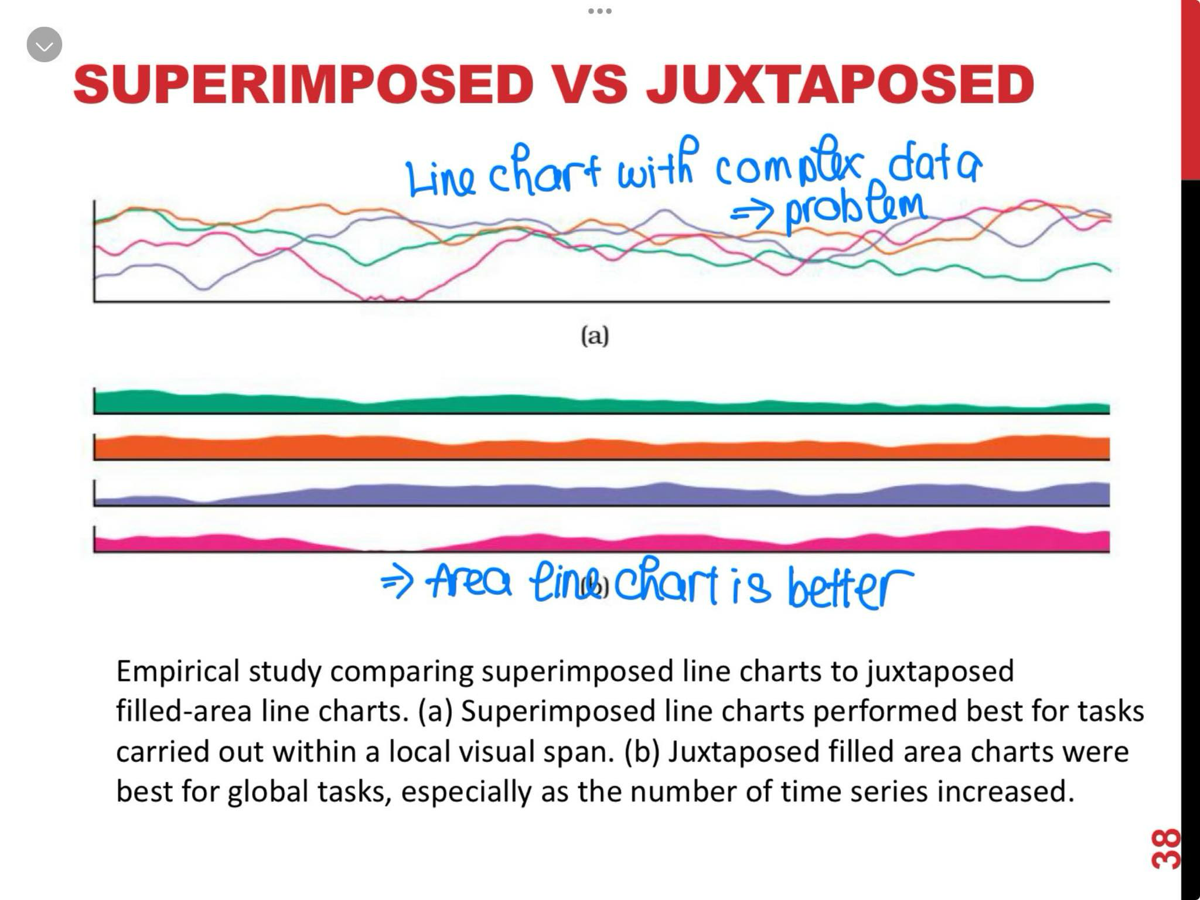

## **DYNAMIC LAYERS**

* For user selection
* The number of possible layers can be huge.
* Huge data -> semantic zooming -> useful.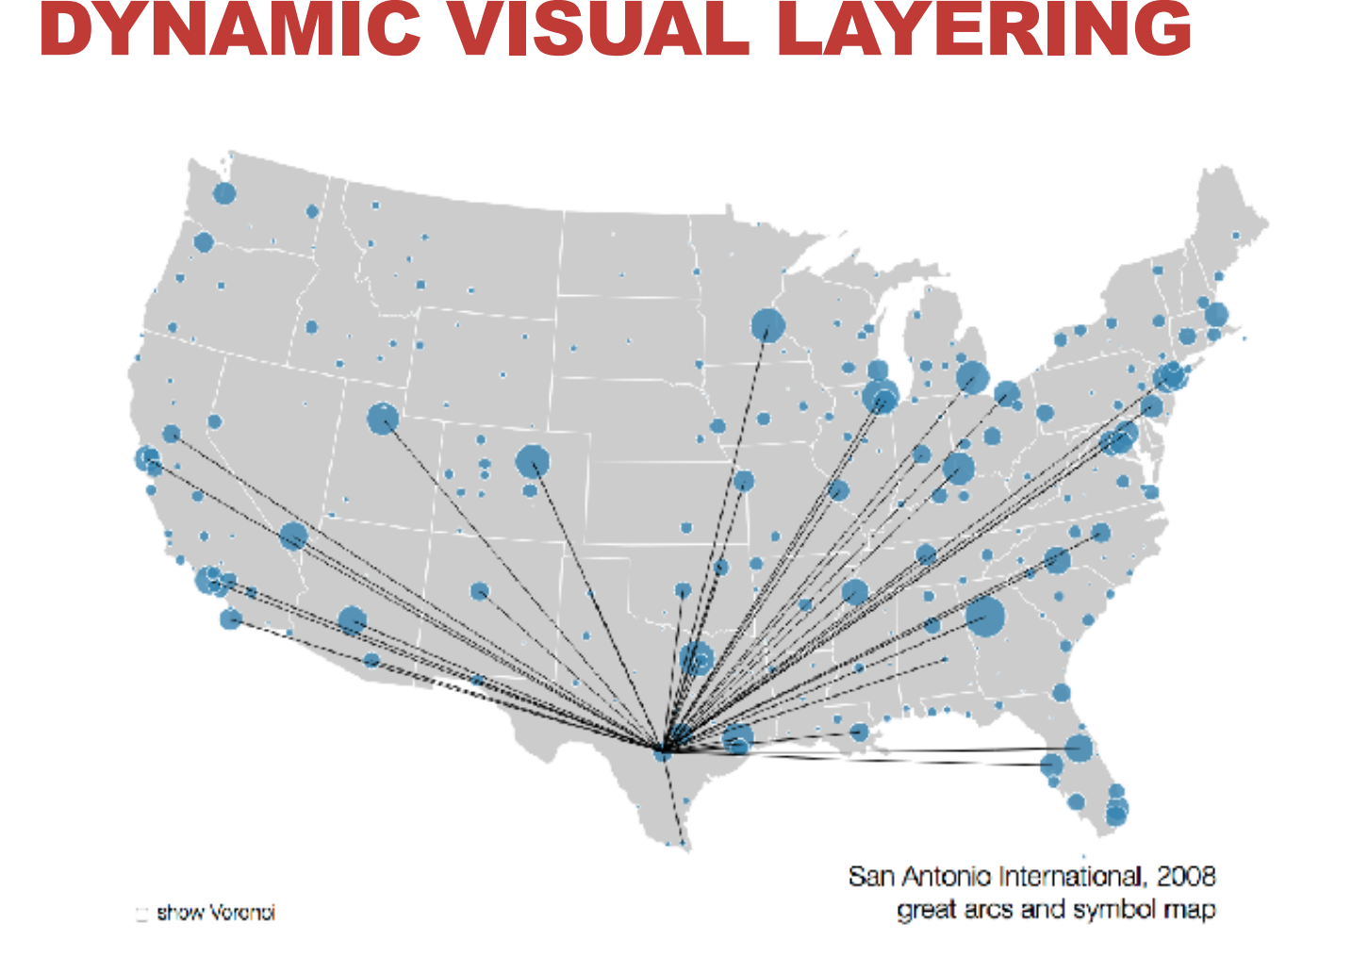

# **EVALUATION**

## **Problem-driven vs Technique-driven**

### **Problem-driven**

* + Identify a problem that people have.
  + Design a solution to help users work more effectively.
* The problem leads to your project which is called problem statement.

### **Technique-driven**

* + Bottom-up approach
  + Invent new visualization techniques or algorithms.
  + Classify or compare against other idioms and algorithms.

## **The nested model (important)**

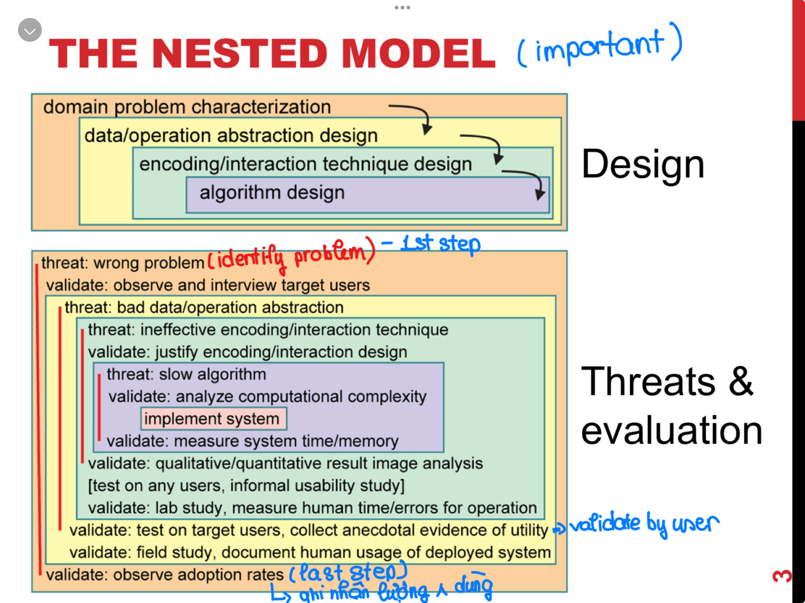

Design Process

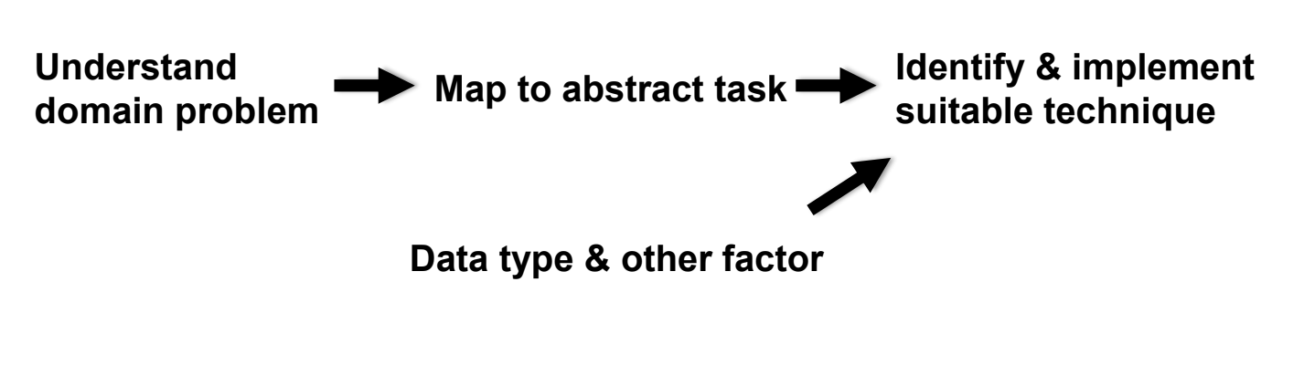

### *Domain Characterization*

* Details of an application domain
* Group of **users**, **target domain**, **their questions**, **their data**
* Cannot just ask people what they do.

🡺 Observe and see.

* Infinite numbers of domain tasks
* Can be broken down into simpler abstract tasks.
* Know how to address the abstract class.

🡺 Identify task 🡪 data combination: solution probably exist.

### *Data & task abstraction*

* The what-why, map -> generalized terms
* Identify tasks -> user wish to perform or already do.
* Find data types + good models of the data.

🡪 Sometimes must transform the data -> for better solution 🡺 varied and guided by the specific task.

### *Encoding & Interaction*

* Visual encodings
* Interactions
  + *Way* 🡪 *create* and *manipulate* the *visual representation of data*.
  + *Decisions* on these may be *separated or intertwined.*
  + *Visualization design* principles *drive decisions*.

### *Tasks*

#### **Analyze**

* + High-level choices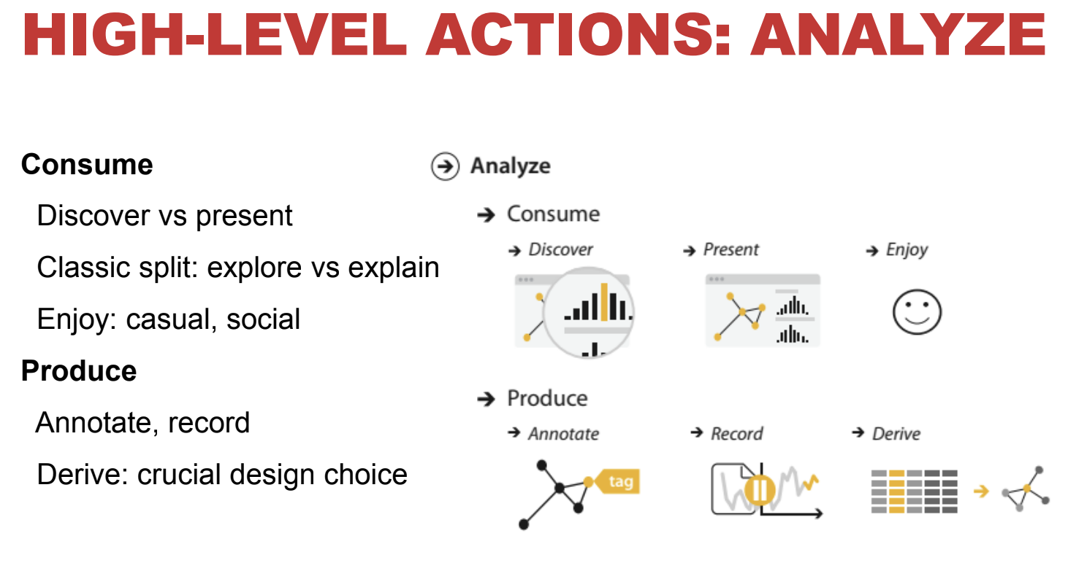
  + Consume vs produce.

#### **Search**

* + Find a known/unknown item.

#### **Query**

* + Find out about characteristics of item.
  + By itself or relative to others

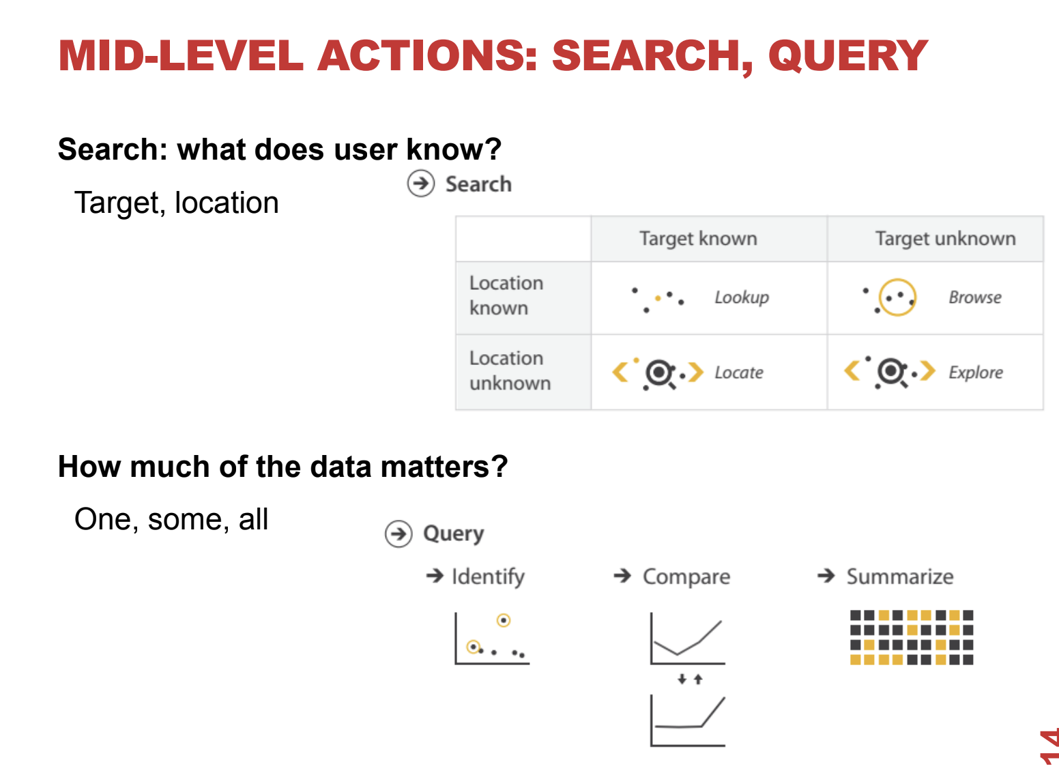

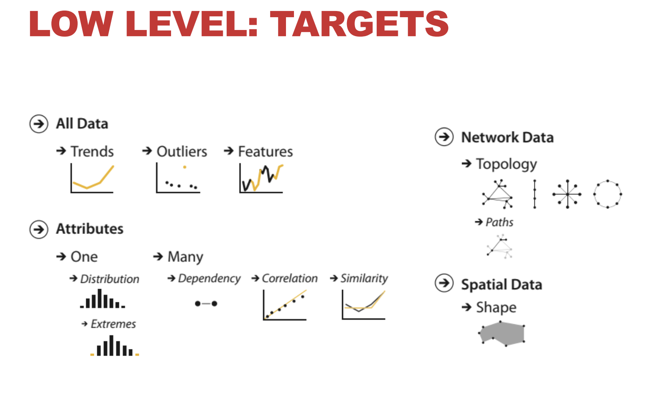

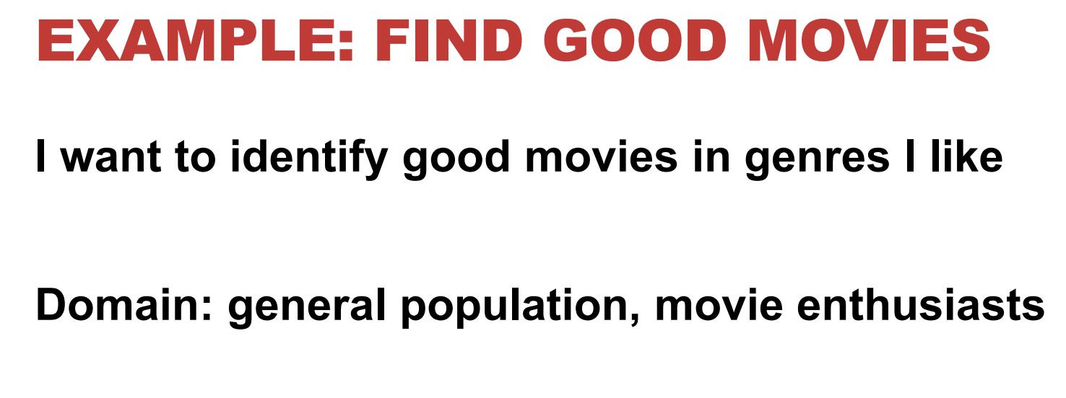

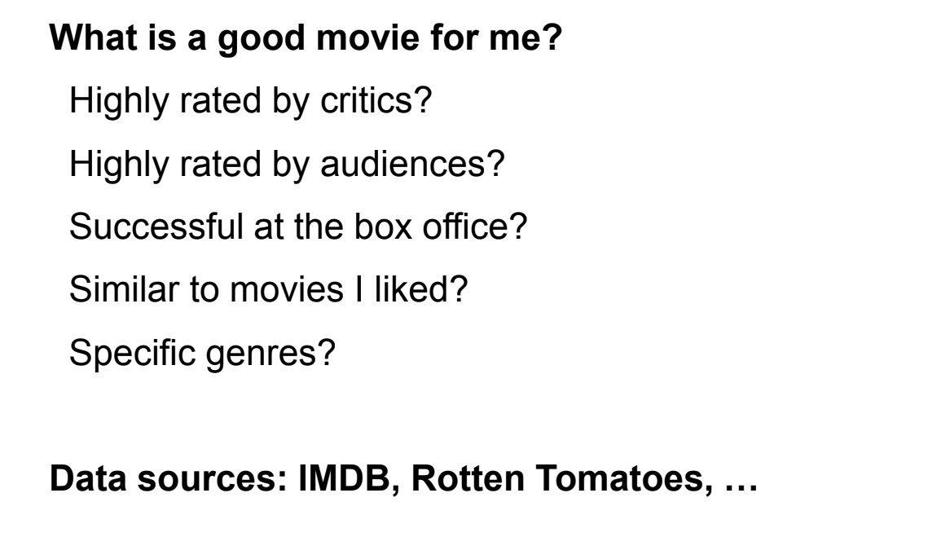

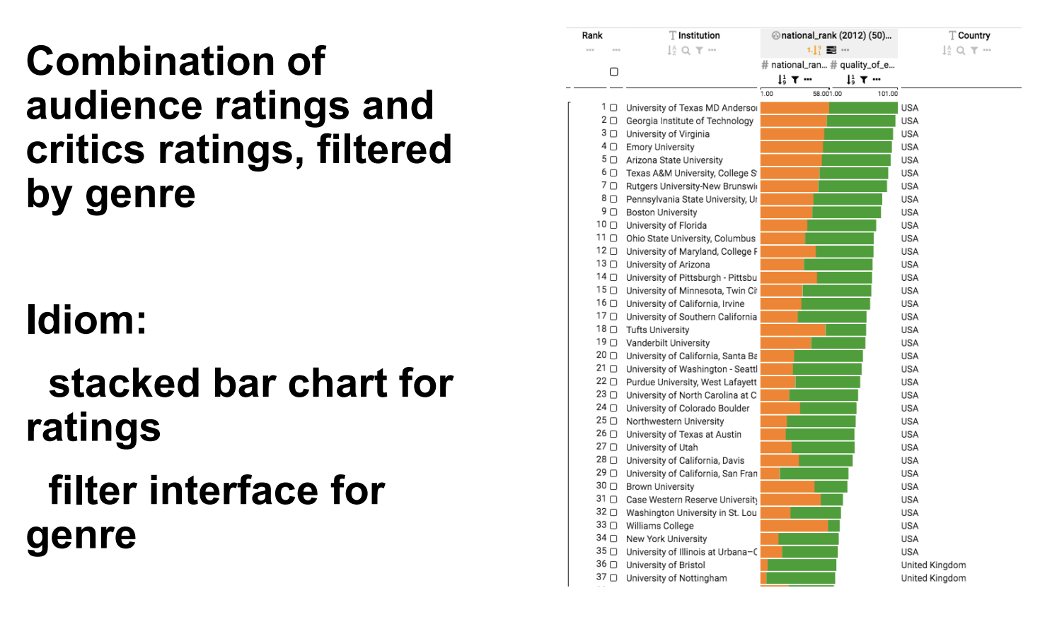

## **DESIGNING VISUALIZATIONS**

### What is design?

* Creating something new -> solve a problem.
* Can be used 🡪 buildings, chairs, user interfaces, etc.
* Design for many fields
* Lots of possible user or tasks.

### What is design not?

* Making things pretty.
* Art
* Without clear purpose
* Without justification or evidence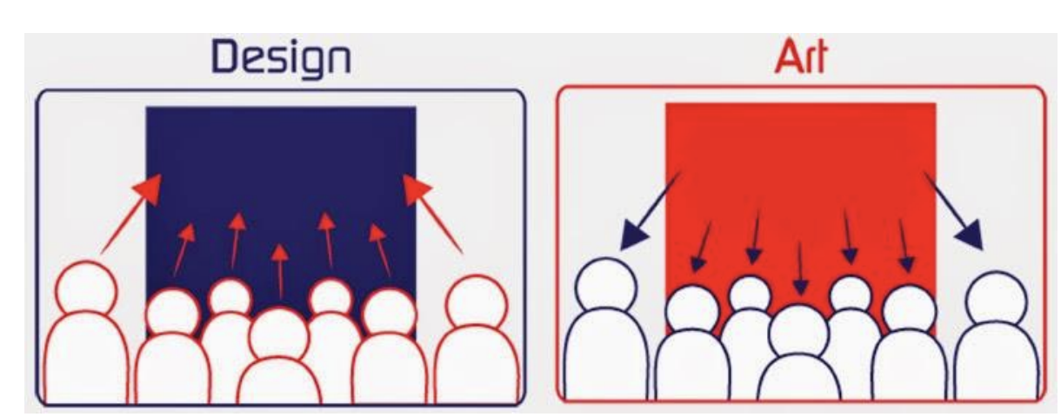

### Form & function

🡪 Form follows function.

### When do we design?

* Some wicked problems:
  + No clear problem definition.
  + Either good enough or not good enough solutions
  + Not true/false, multiple solutions exit.
  + No clear point to stop with a solution.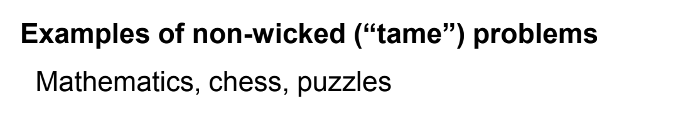

### Why does design matter for vis?

* Many ineffective visualization combinations.
* Users with unique problems & data.
* Variations of tasks.
* Large design space.

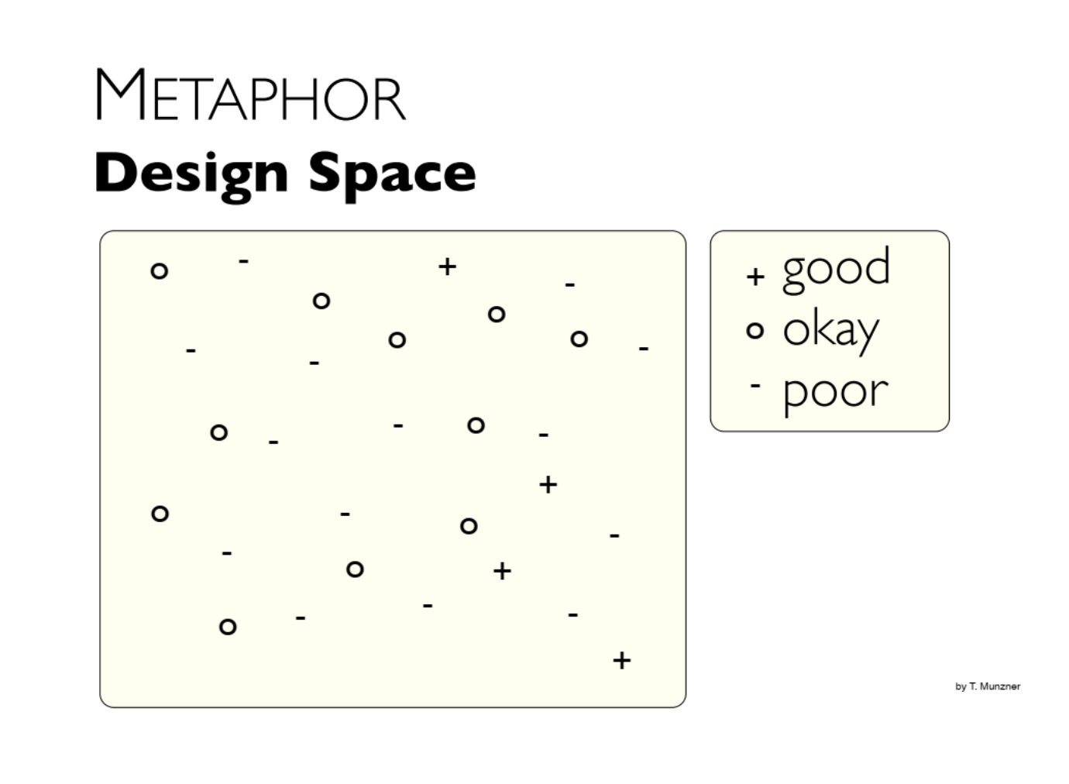

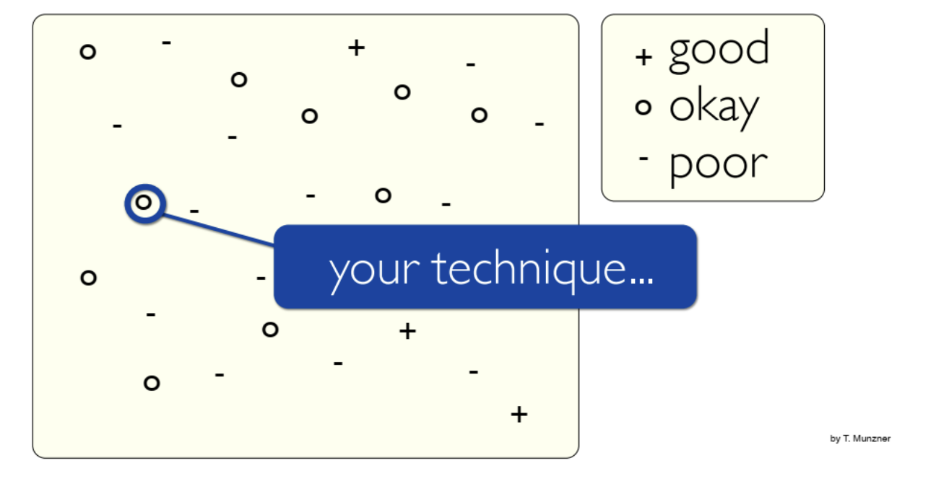

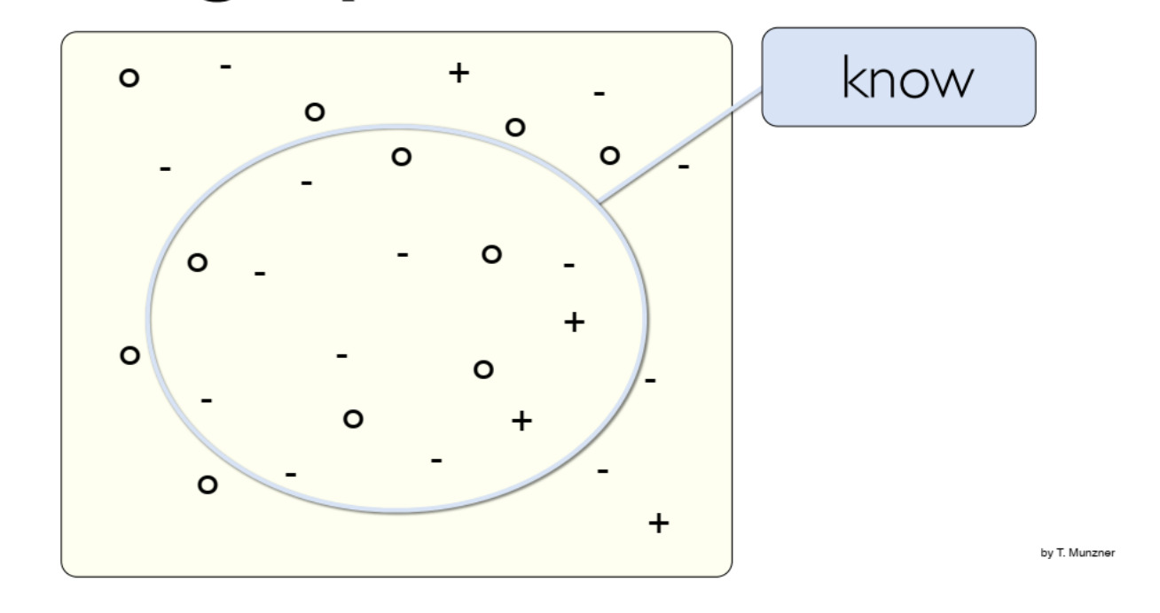

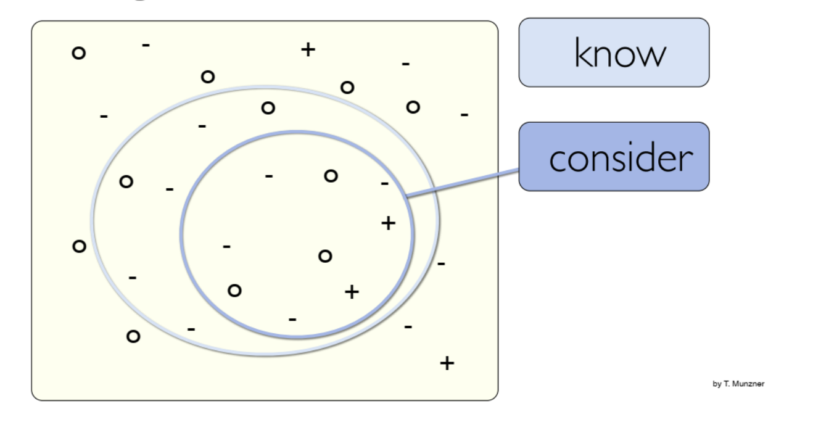

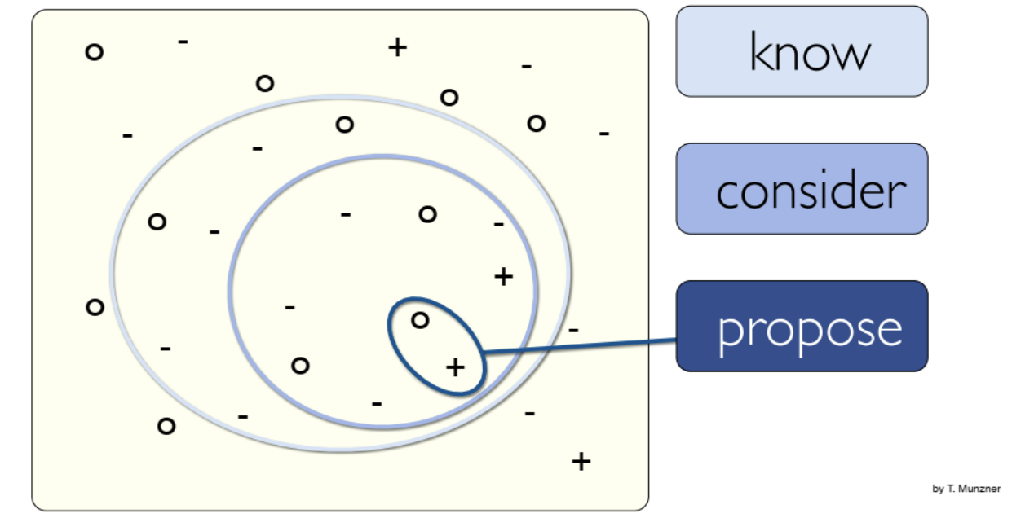

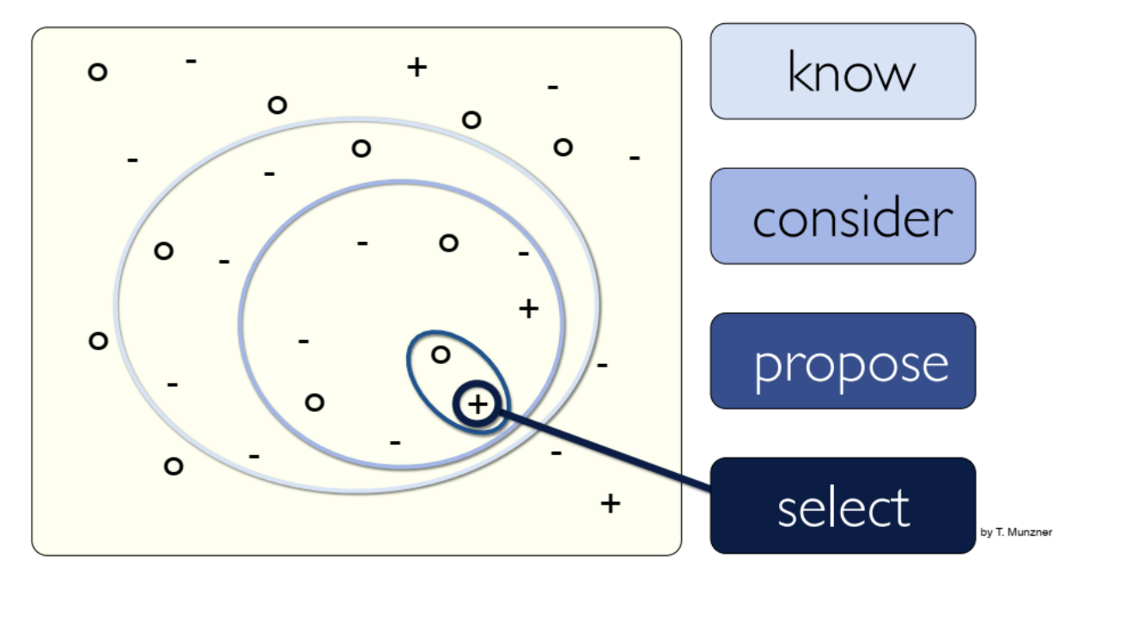

### Evaluation methods

* **Controlled experiment** => Ex: Laboratory, crowd-source.
* **Interviews/questionaries** => Unstructured, structured, semi-structured.
* **Field observation, lab observation** => video/audio analysis, Coding/classification of user behavior (speech, gestures)
* **Log analysis**
* **Algorithmic performance measurement.**
* **Heuristic evaluation** => Recognizing metrics/usability methods for judging compliance.
* **Usability testing** => Ex: thinking aloud tests
* **Wizard of Oz**
  + Human simulates response of system.
  + Test functionality before it’s implemented.
* **Eye tracker evaluation**
* **Expert evaluation**
* **Insight-based evaluation**
* **Case studies.**

### Quantitative vs Qualitative evaluation

#### Quantitative methods

* Object metrics, measurements.
* User numbers/statistics for interpreting data.

#### Qualitative methods

* Subjective metrics.
* Descriptions of situations, events, people, interactions, and observed behaviors, the use of direct quotations from people about their experiences, attitudes, beliefs, and thoughts.
* Focused on understanding how people make meaning of an experience their environment or world.

### Internal vs external validity

#### Internal validity

* High <-> tested under controlled lab conditions.
* Observed effects <- test condition (noy random variables)

1. 🡪 experiment representative of real world usage.

* High <-> interface is tested in the field.
  + Ex: Handled device tested in museum
* Results -> valid in real world

#### The trade-off

* More akin to real-world situation -> more experiment is susceptible (dễ bị ảnh hưởng) to uncontrolled sources of variation.

# **Review with TA**

1. Theory. (interaction, design process, evaluation)
2. Interaction

1. Static content: infographics, books + dynamic content: animated in auto-play, interactive content.

2. Need to interact b/c exploring data that is big/complex -> amplifies cognition.

3. Direct manipulation: interact directly with object + indirect interact (không cần tương tác)

4. Type 🡪 Single view: overtime, navigation, semantic zooming, focus

🡪 Multiple views: selection, linking, brushing, adapting representation.

5. Change over time: chỉ ra những điểm khác biệt một cách rõ ràng.

6. Transition: theo dõi những gì đang thay đổi.

7. Animation caveats: những animation có mà người dùng có thể nhận ra được

8. Navigations: pan, zoom, rotate.

9. Scrolltelling

10. Semantic zooming: khi zoom ra sẽ thấy sự thay đổi

11. Focus + Context: gồm ba dạng (aggregation, reduction, layering)

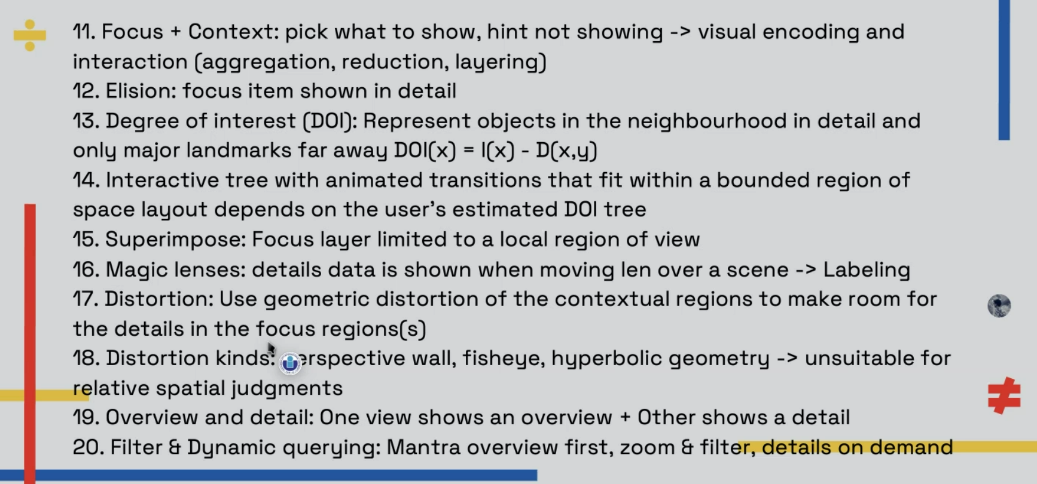

DOI: mức độ quan tâm

1. Views

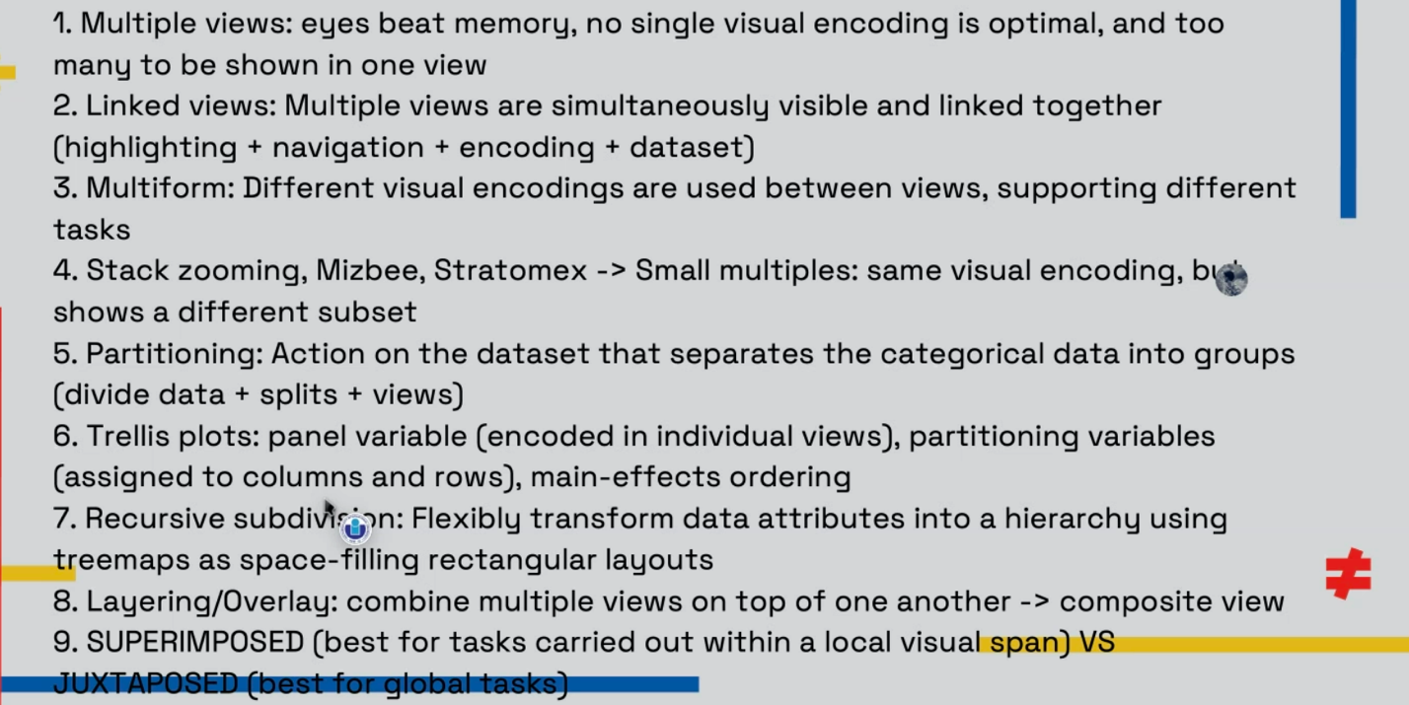

* Tuỳ mục đích khi lựa chọn giữa small multiples (sự thay đổi không nhiều khi biểu diễn dưới dạng multiple views), và ngược lại.

1. Tables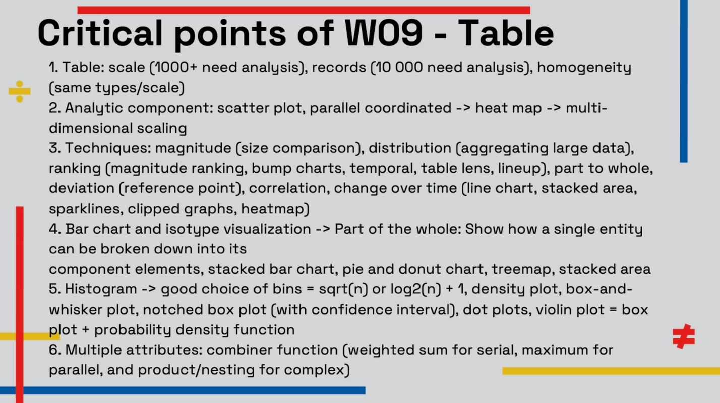

Scale table:

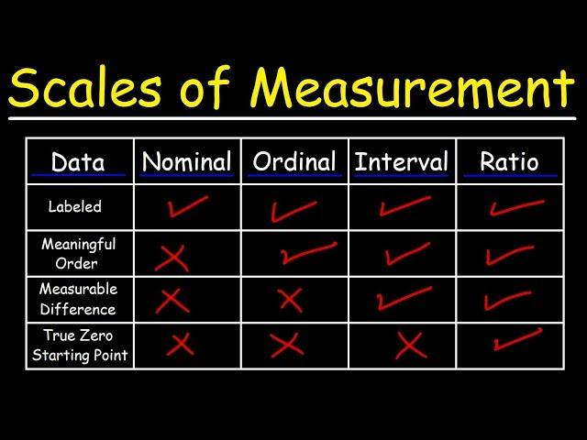

**Muốn scale table có thể xem xét:**

* Scatter plot
* Parallel coordinate
* Heat map
* Multi dimension scaling
* Histogram là phải group thành từng bins nhỏ

1. Story telling

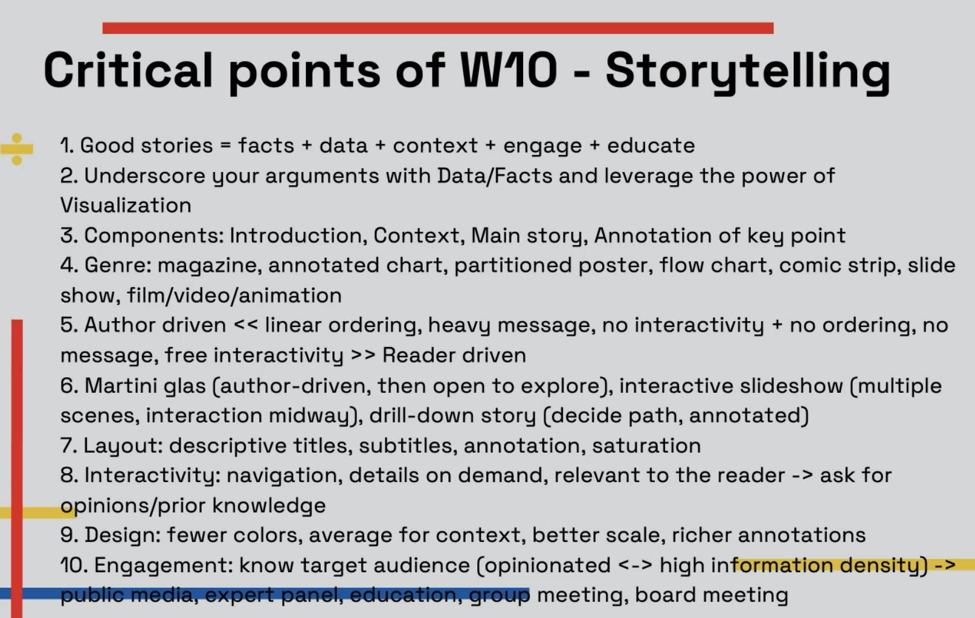

1. INTRODUCTION
2. Context
3. Story #1
4. Annotate key #1 🡪 visualization.
5. Repeat steps 3 & 4

Genre:

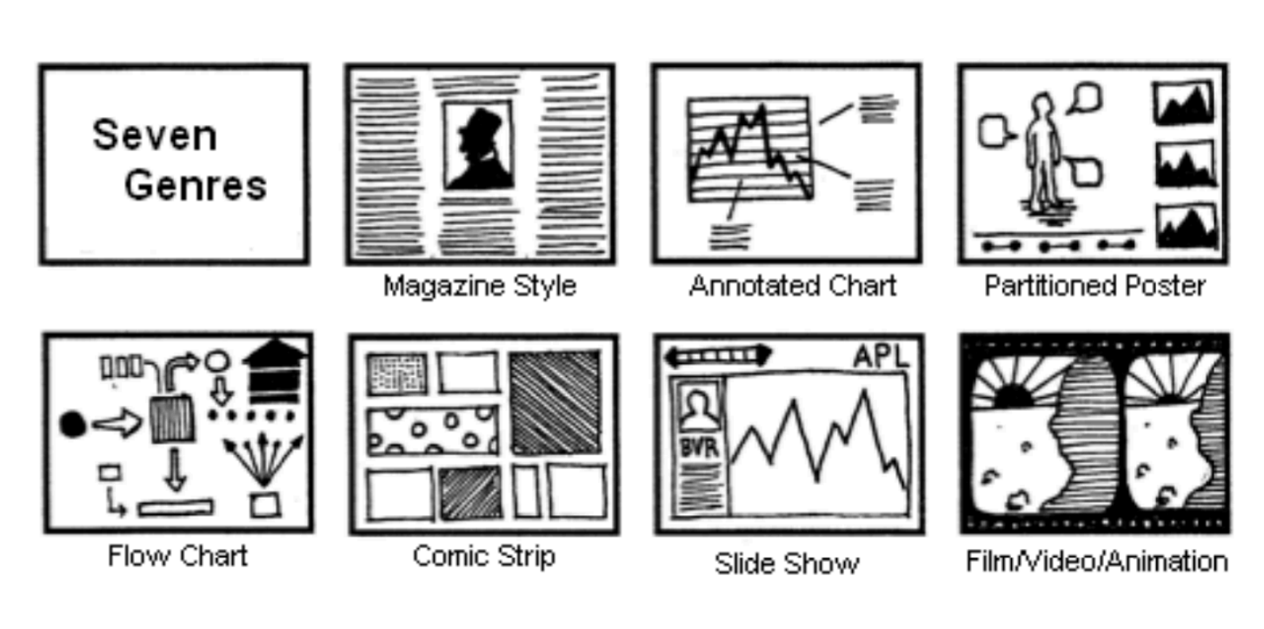

Chú ý: Magazine style, annotated chart, => nếu không biết thì dựa vào phân tích components

Ex:

* Bài báo trên tuổi trẻ => genre: magazine

**Author-driven**: không được tương tác, không cần làm gì hết

**Reader-driven**: cho bạn tự do khám phá, tương tác.

1. Evaluation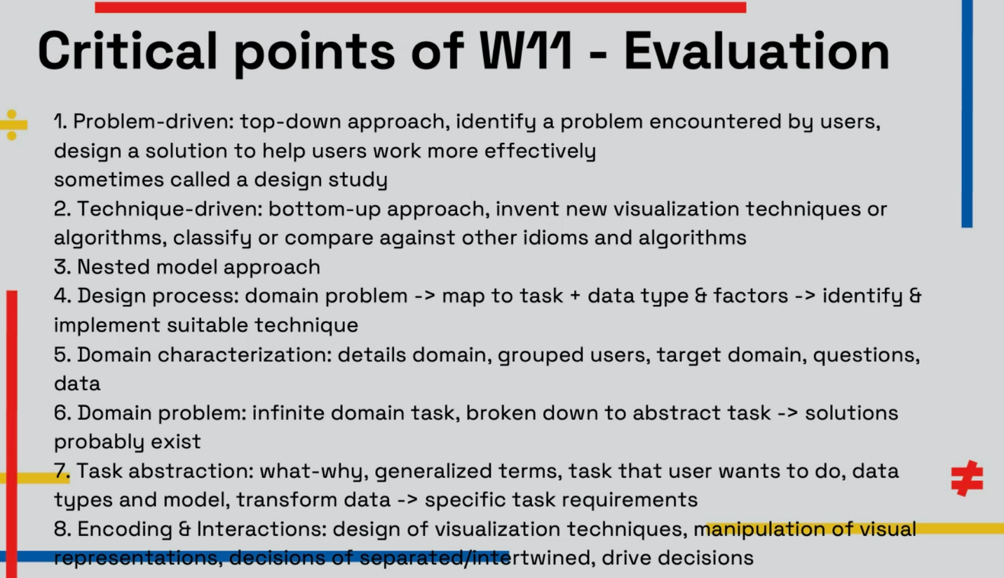
2. Visualization.

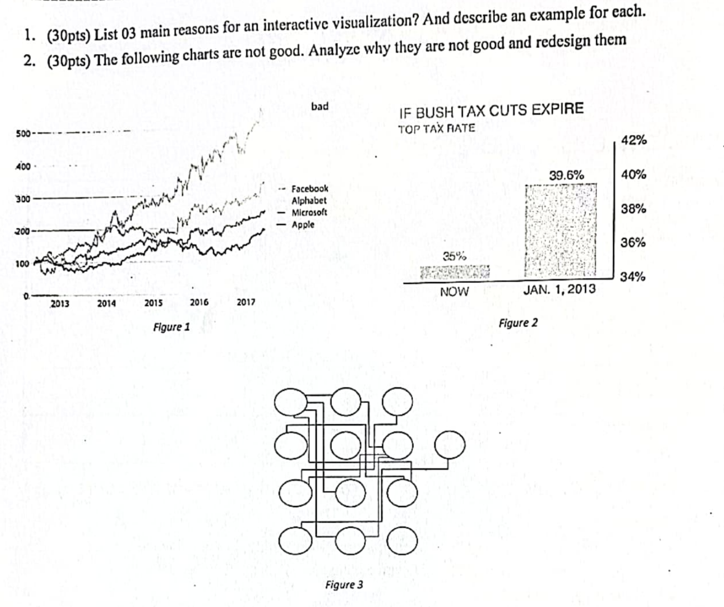

1. Soạn ra trước => chuẩn bị example
2. Figure 3 quá rối, chẳng có liên kết

Redesign: Dang rộng ra

Figure 2: Không tốt => lấy gốc là 34%=> độ chênh lệch 35% và 39,6% do độ chênh lệch được biểu diễn không đúng

Redesign: scale lại đưa về góc 0 => vấn đề về %

Figure 1: Khá rồi nếu không có màu sắc gợi ý => không bao giớ được phép vượt quá cái highest.

Redesign: làm cho smoothly lại + thay đổi màu sắc

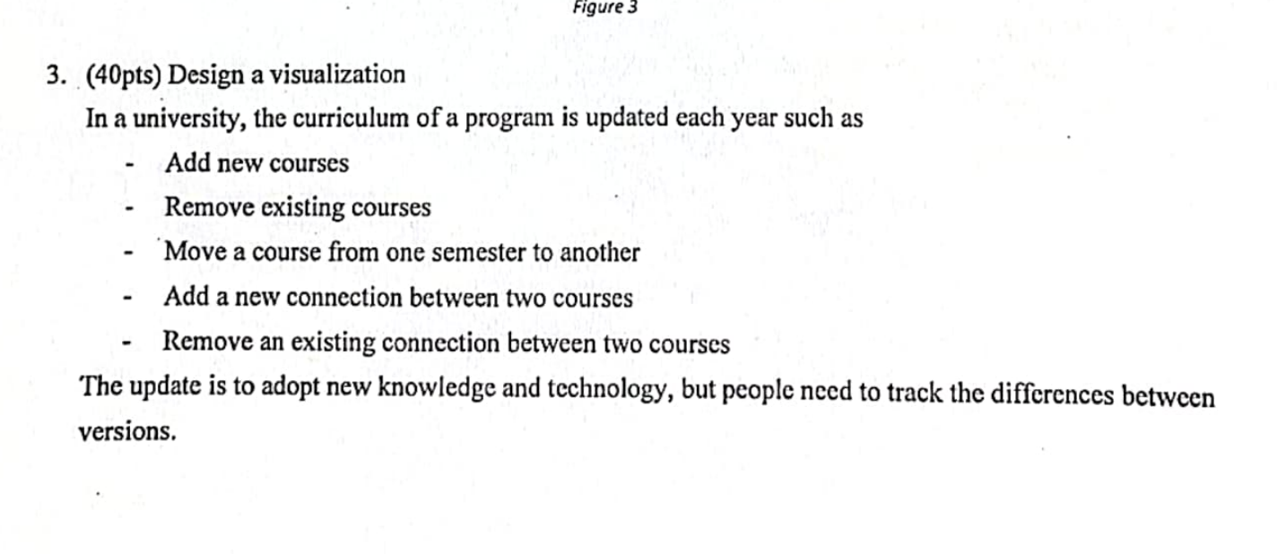

* dùng màu sắc để ký hiệu
* Add một đường nối
* ….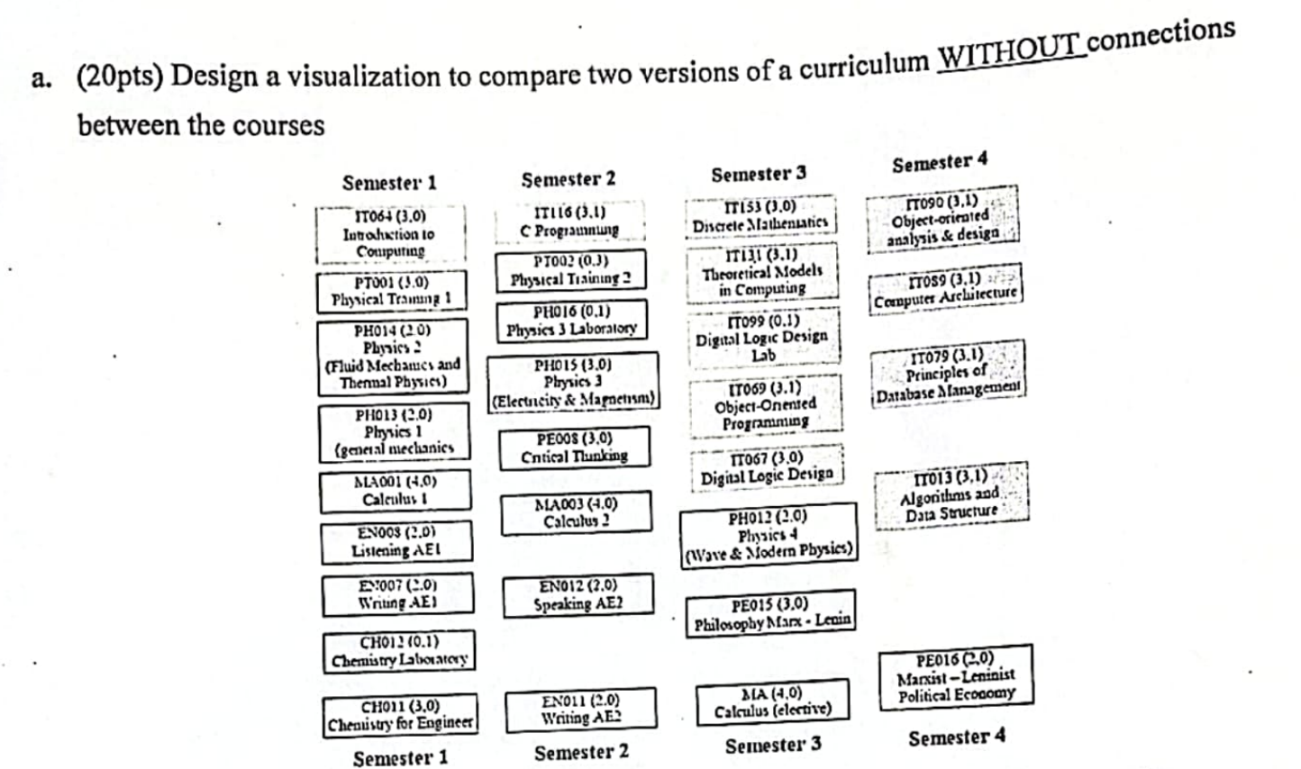

Mới add vô thì để màu sắc

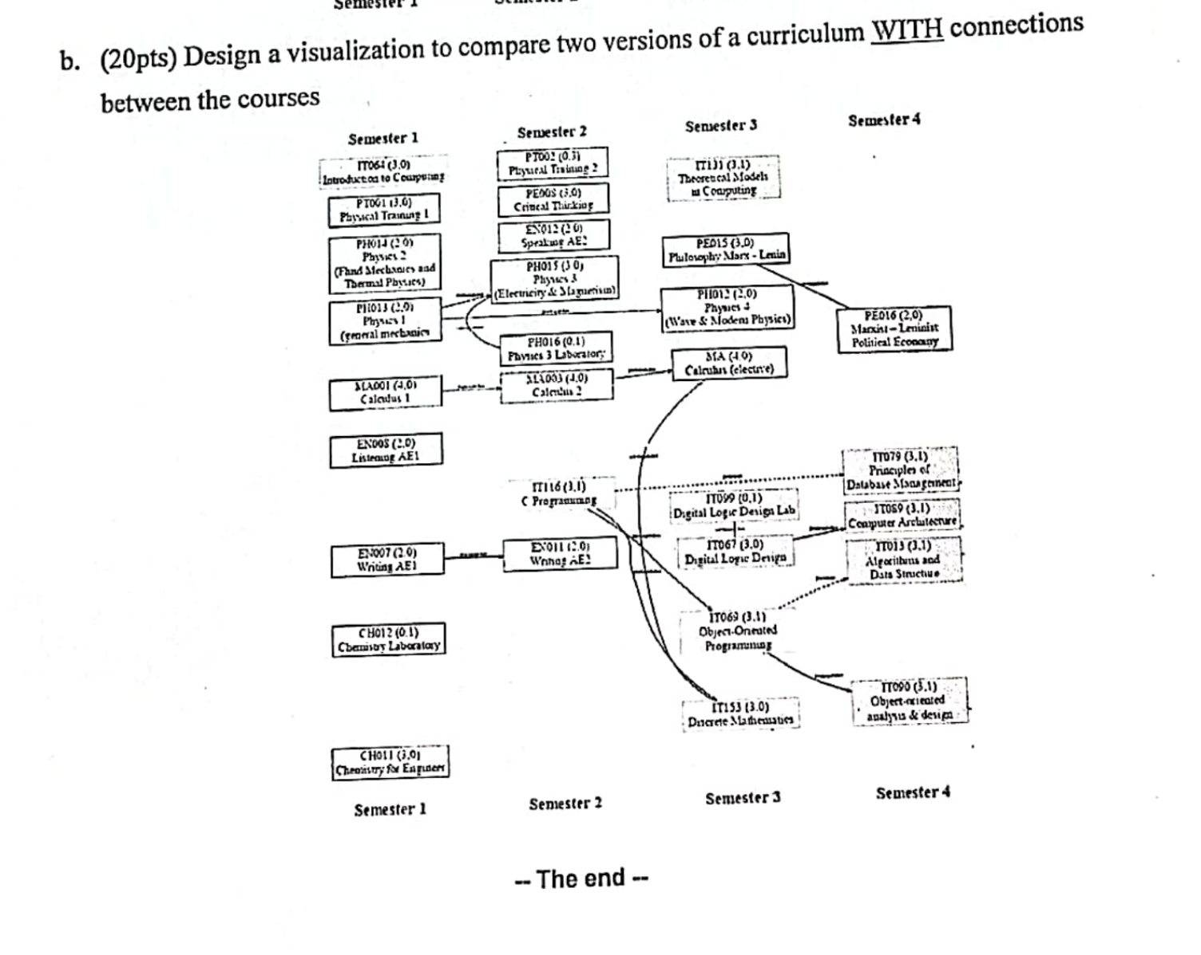

* Do bị rối => thay thế vị trí
* Mới add vô => dùng đường gạch hoặc ký hiệu.

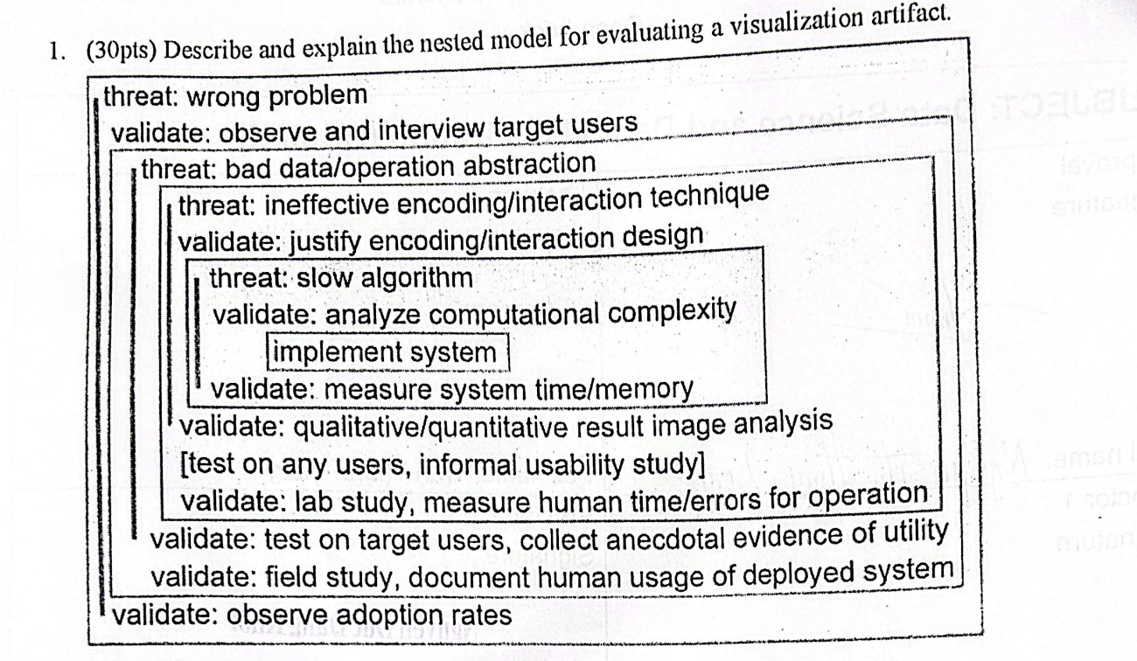

Design:

Domain 🡪 Data(type/chart)[abstract]🡪encoding + interaction🡪 Algorithmic design

Threats & evaluation

Đi từ ngoài vào trong từ threat: wrong problem (cho ví dụ) mục đích của validate: Observe and interview target users 🡪 observe adoption rates 🡪 tiếp tục đi vào trong

Ans:

The image you provided further elaborates on the Nested Model for Visualization Design and Validation. Here’s a detailed explanation with examples:

1. **Threat: Wrong Problem**
   * **Validation**: Observe and interview target users.
   * **Example**: Suppose you’re working with a team of meteorologists who need to predict weather patterns. [The domain problem could be predicting the likelihood of rainfall in a certain area, and the data could be historical weather data, including temperature, humidity, wind speed, etc1](https://www.cs.ubc.ca/labs/imager/tr/2009/NestedModel/NestedModel.pdf).
   * **Explanation**: Ensure that the visualization addresses a relevant and significant problem by engaging with end users.
2. **Threat: Bad Data/Operation Abstraction**
   * **Validation**: Justify data/operation abstraction.
   * **Example**:The patterns or trends can be defined by the operation in the weather data, and the data types could be time-series data (temperature, humidity level, and so on) and geographical data( the locations of the weather stations).
   * **Explanation**: Validate that the data used, and operations performed are appropriate, accurate, and reliable.
3. **Threat: Ineffective Encoding/Interaction Technique**
   * **Validation**: Justify encoding/interaction design.
   * **Example**: You might decide to use a line graph to represent the change in weather patterns over time, with different lines for different weather stations. The x-axis could represent time, and the y-axis could represent the weather measurement (like temperature or humidity). This let users to interact with the graph by choosing a time range to view detailed data or hovering over a line to see more information or the exact data values.
   * **Explanation**: Ensure that visual encodings and interactions effectively convey information.
4. **Threat: Slow Algorithm**
   * **Validation**: Analyze computational complexity; implement system.
   * **Example**: You would need an efficient algorithm to handle potentially large amounts of weather data and to update the line graph quickly in response to user interactions. Data indexing, aggregation, and optimized query is also involved.
   * **Explanation**: Evaluate if the algorithm’s performance is efficient enough for practical use.

The image also provides additional validations:

* Measure system time/memory,
* Conduct qualitative/quantitative result image analysis,
* Perform lab studies to measure human time/errors for operation,
* Test on target users, collect anecdotal evidence of utility,
* Document human usage of deployed system in field studies,
* Observe adoption rates to gauge user acceptance.

This model helps in identifying the right problems, creating suitable abstractions, designing effective visual encodings and interactions, and implementing efficient algorithms. The validation process is guided to make sure that the effectiveness and efficiency for evaluating the visualization artifacts.

* Genres: Magazines styles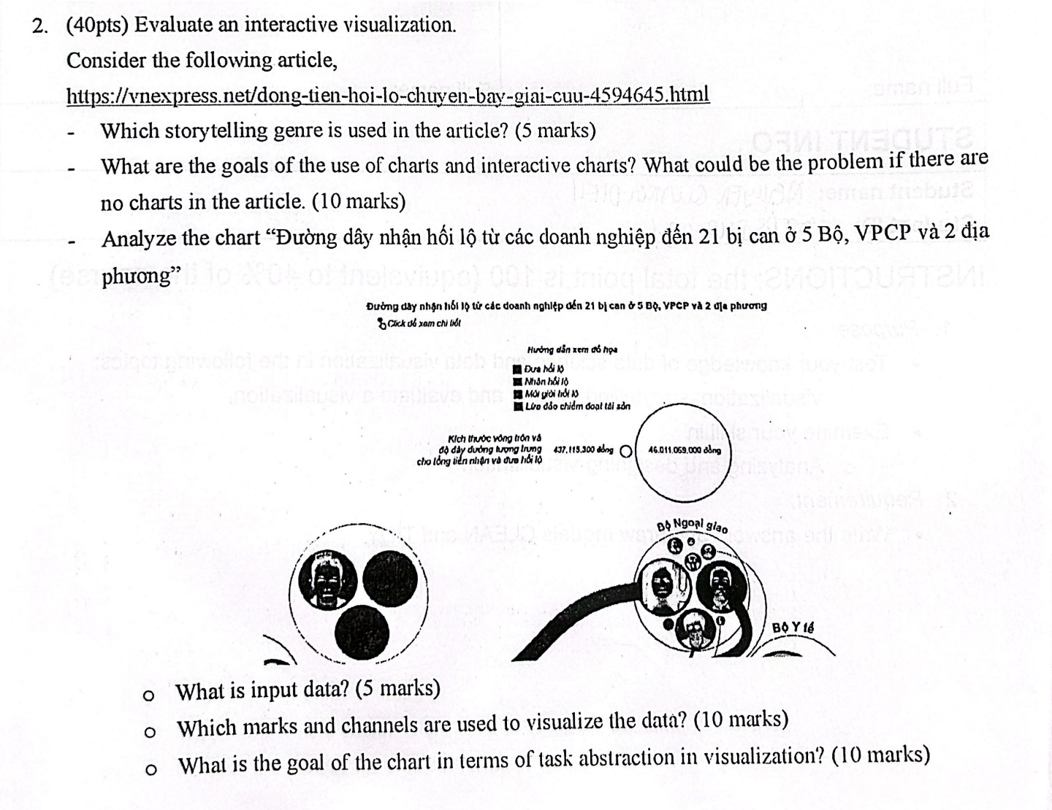
* Goal: giúp người đọc hiểu về câu chuyện bên trong + tính toán mức độ thiệt hại trong câu chuyện+ mối liên kết giữa các nhân vật trong câu chuyện trong đó (nếu không có chảt sẽ thiếu tính enagement, khó tưởng tượng, khó tiếp nhận thông điệp, rất khó để keep track đc câu chuyện xảy ra ntn)
* Input data: Tên, hình, cái hướng di chuyển của dòng tiền, cái số tiền nhận hối lộ bao nhiêu, thể hiện relationship bằng các hình tròn, thêm số tiền hối lộ.
* Mark: line, circle.

Channel: size of circle, color, length.

* Goal: bổ sung context => hiểu đc đường dây rộng như thế nào => reader driven mindset => không bị ép buộc bởi tác giả=> biểu diễn chi tiết hơn

1. Code

* Map
* Interact
* Zoom
* Tooltip
* Visualization
* Code
* Test bank.